**MANUAL TESTS**

**Syed Mudabbir**

**Alexander Ferrard**

**Ayush Patel**

**Team Expressionary**

**USER STORY #3**

**Test No.1**

User Login field exists, a prompt pops up when login is pressed

**Procedure:**

* Navigate to the home page of them website and Press Login
* Validate the response,
* Press Cancel
* Validate the response

**Test**

Navigate to the home page

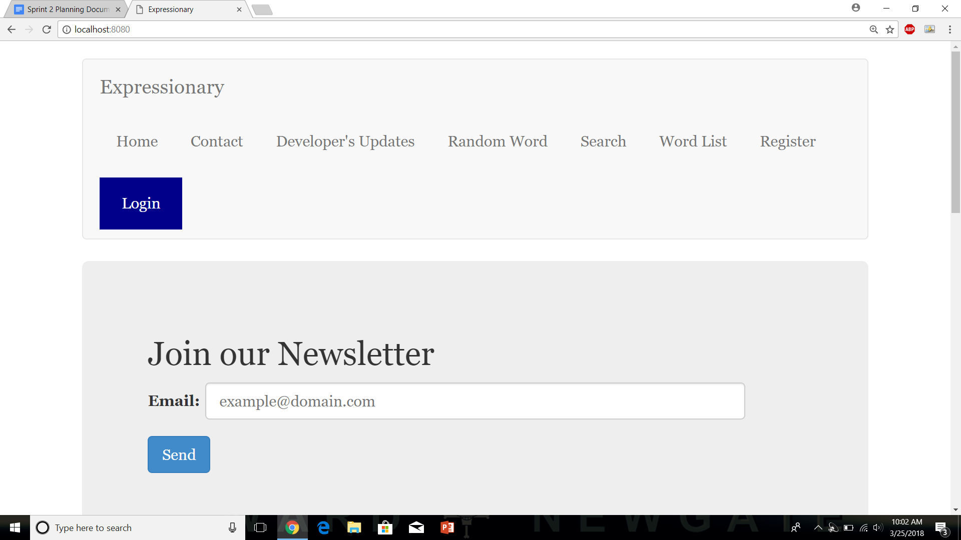

Press Login

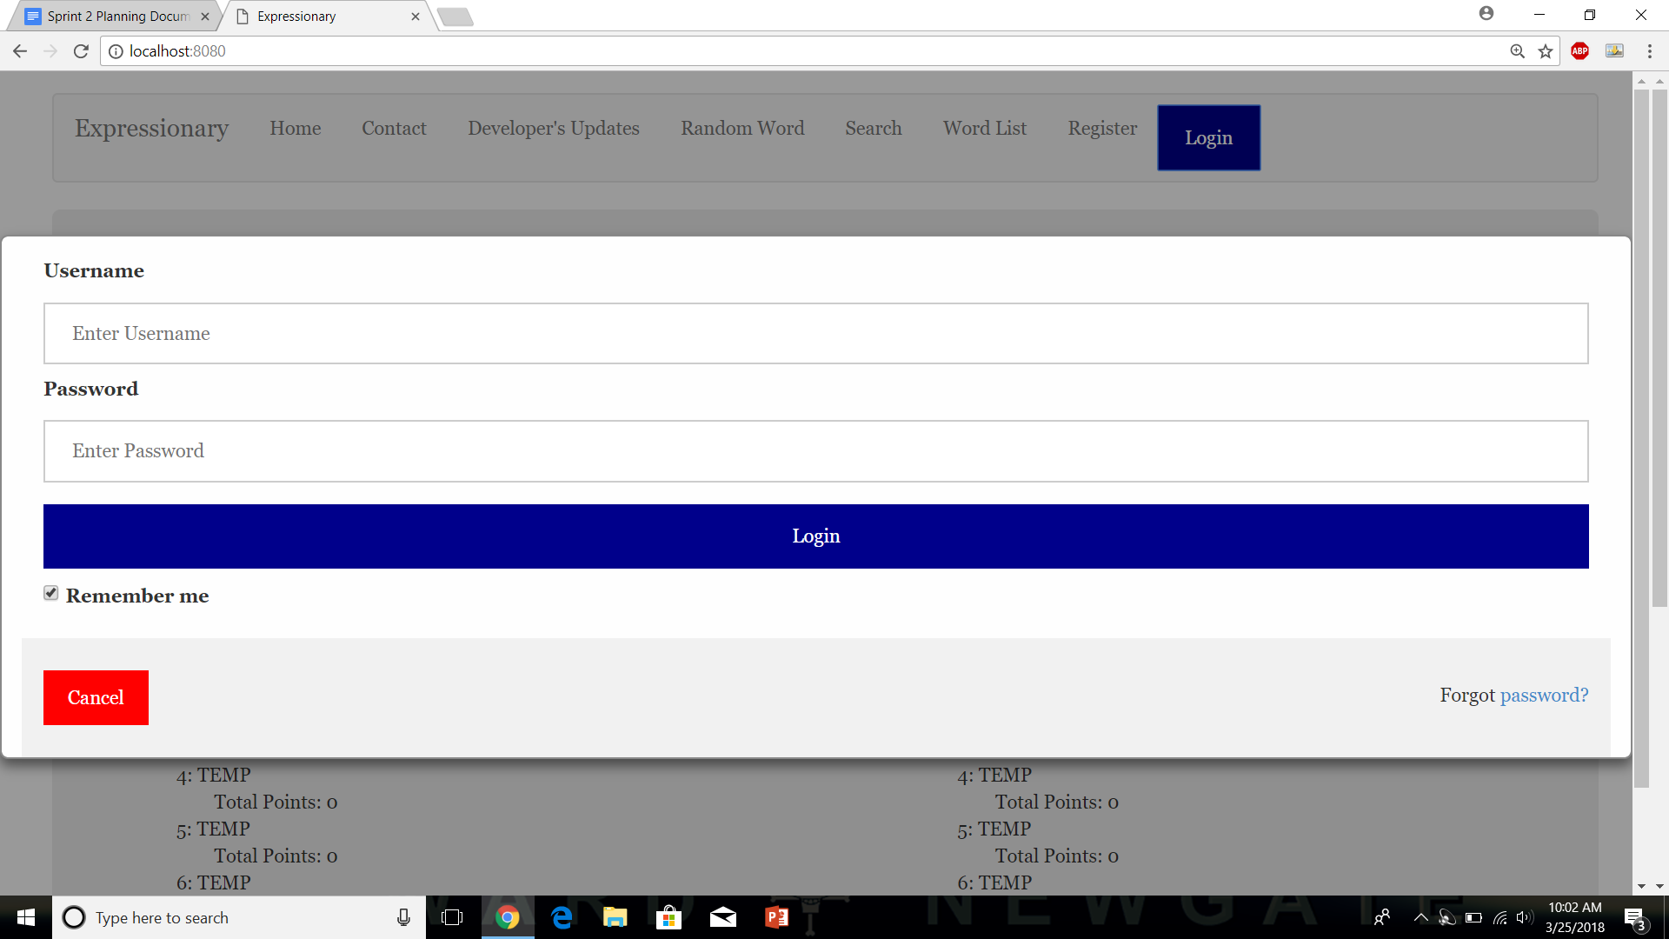

Press Cancel



**Results:**

The Front-End GUI seems to work fine under normal use, the pop up opens and closes the way it should.

**Test No.2**

Pressing Login and Cancel multiple doesn’t break the program

**Procedure:**

* Navigate to the home page of them website and Press Login
* Validate the response,
* Press Cancel
* Validate the response
* Repeat multiple times
* Report unexpected behavior

**Test**

Navigate to the home page



Press Login



Press Cancel



Repeat a few times.

**Results:**

Even with multiple tries the program doesn’t break and works like expected

**Test No.3**

Existing Users can log in and a prompt is there to display that

**Procedure:**

* Navigate to the home page of them website and Press Login
* Enter Valid credentials
* Press Login
* A “Login Successful” prompt should be displayed
* Validate the response

**Test**

Navigate to the home page



Press Login



Enter the Credentials and Press Login

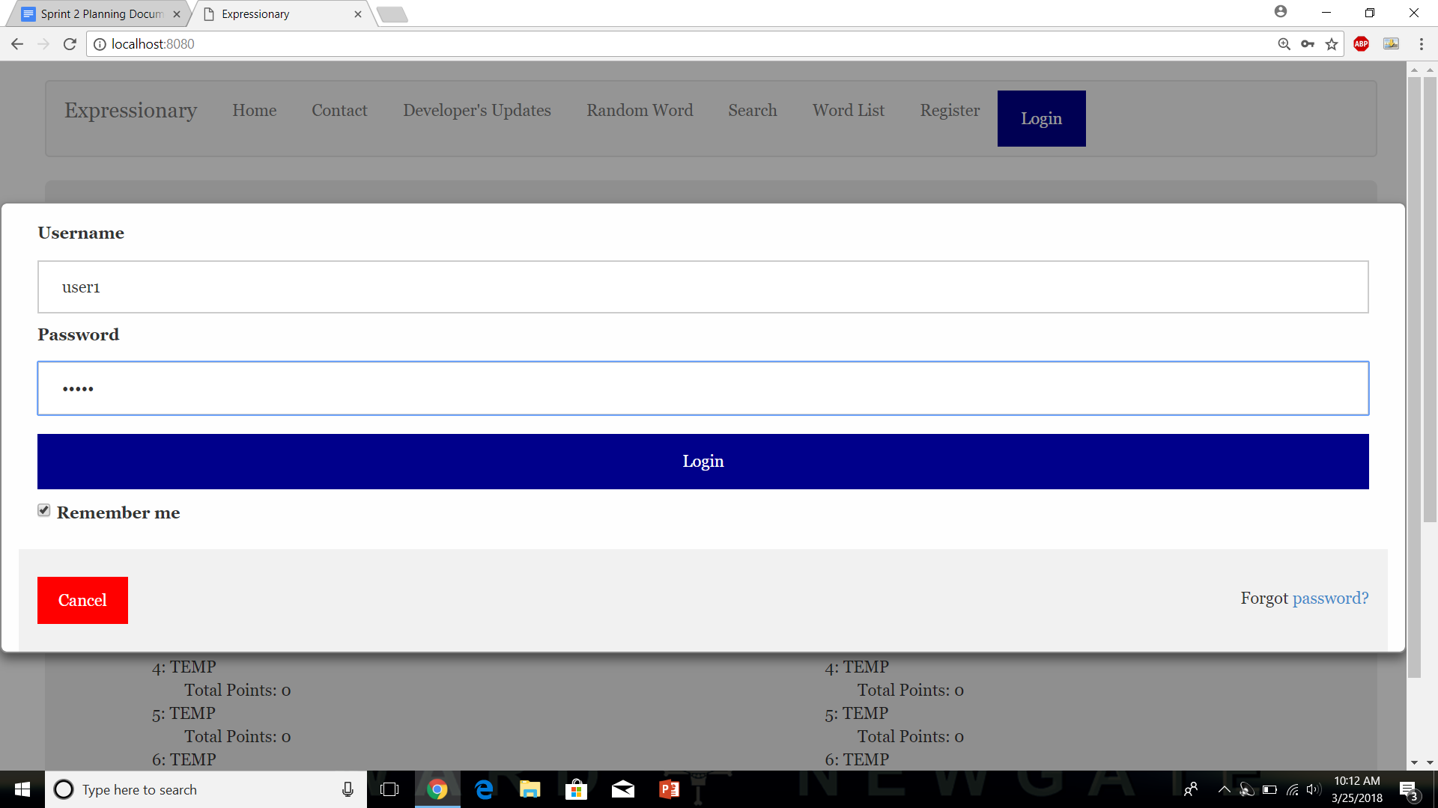

Display is showed with status

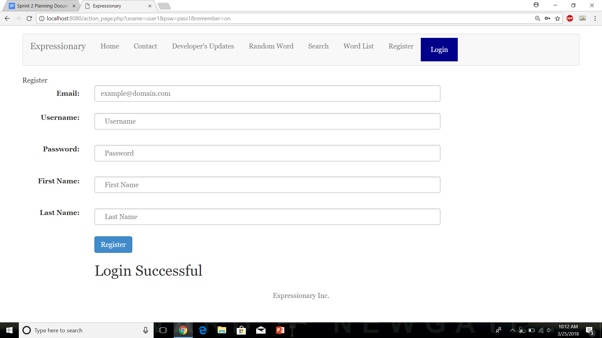

**Results:**

Registered Users can log in successfully.

**NOTE: I will not be writing or showing the 2 parts of the procedure namely**

* Navigate to the home page of them website and Press Login

**As they will be happening in every test and are the same, however, any problems, if they occur, will be reported.**

**Test No.4**

Trying to log in with an already logged in user, should not work

**Procedure:**

* Login with a user that is already Logged in
* Press Login
* Status message should show user not being able to be logged in
* Report unexpected behavior

**Test**

Enter Credentials



Status message is displayed saying User Already Logged in

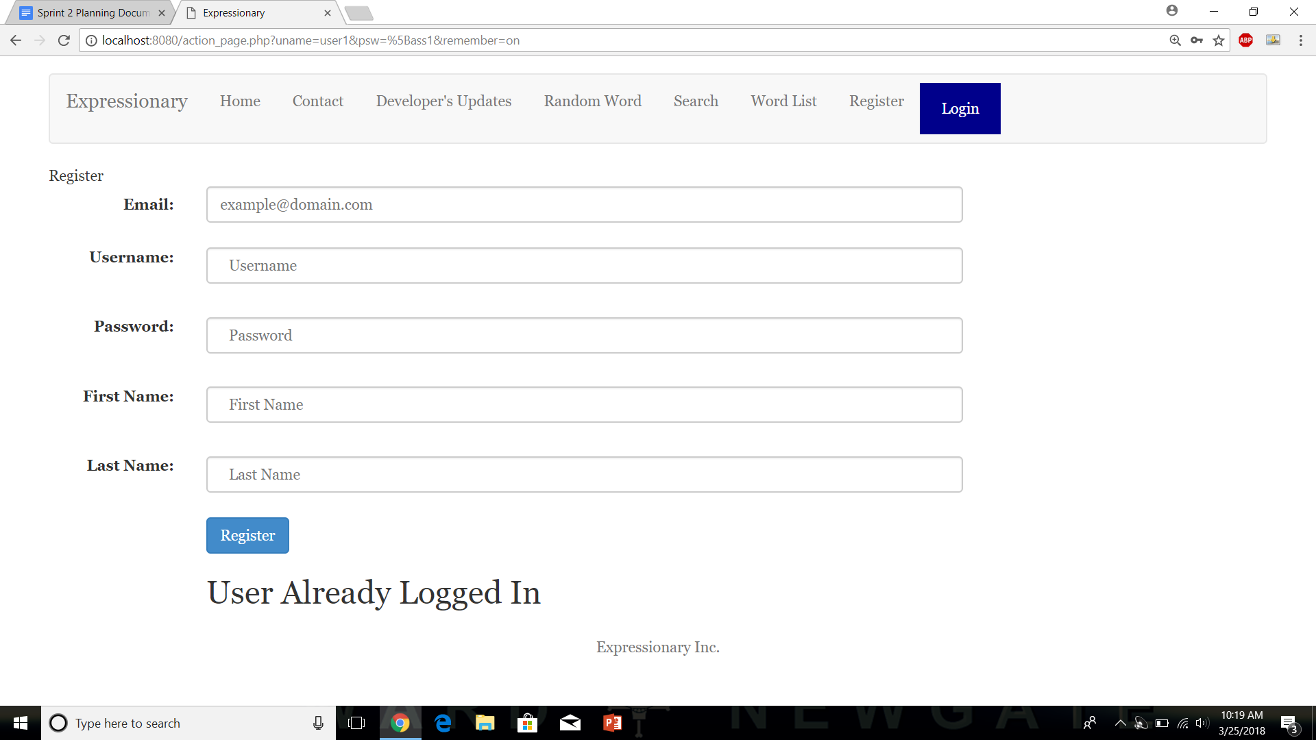

**Results:**

If a user if already logged in, they cannot login again, multiple logins are not allowed

**Test No.5**

Logging in with a non -registered user should not work, User must register first

**Procedure:**

* Enter credentials for a user that doesn’t exist
* Press Login
* Record the response
* Report unexpected behavior

**Test**

Enter invalid Credentials

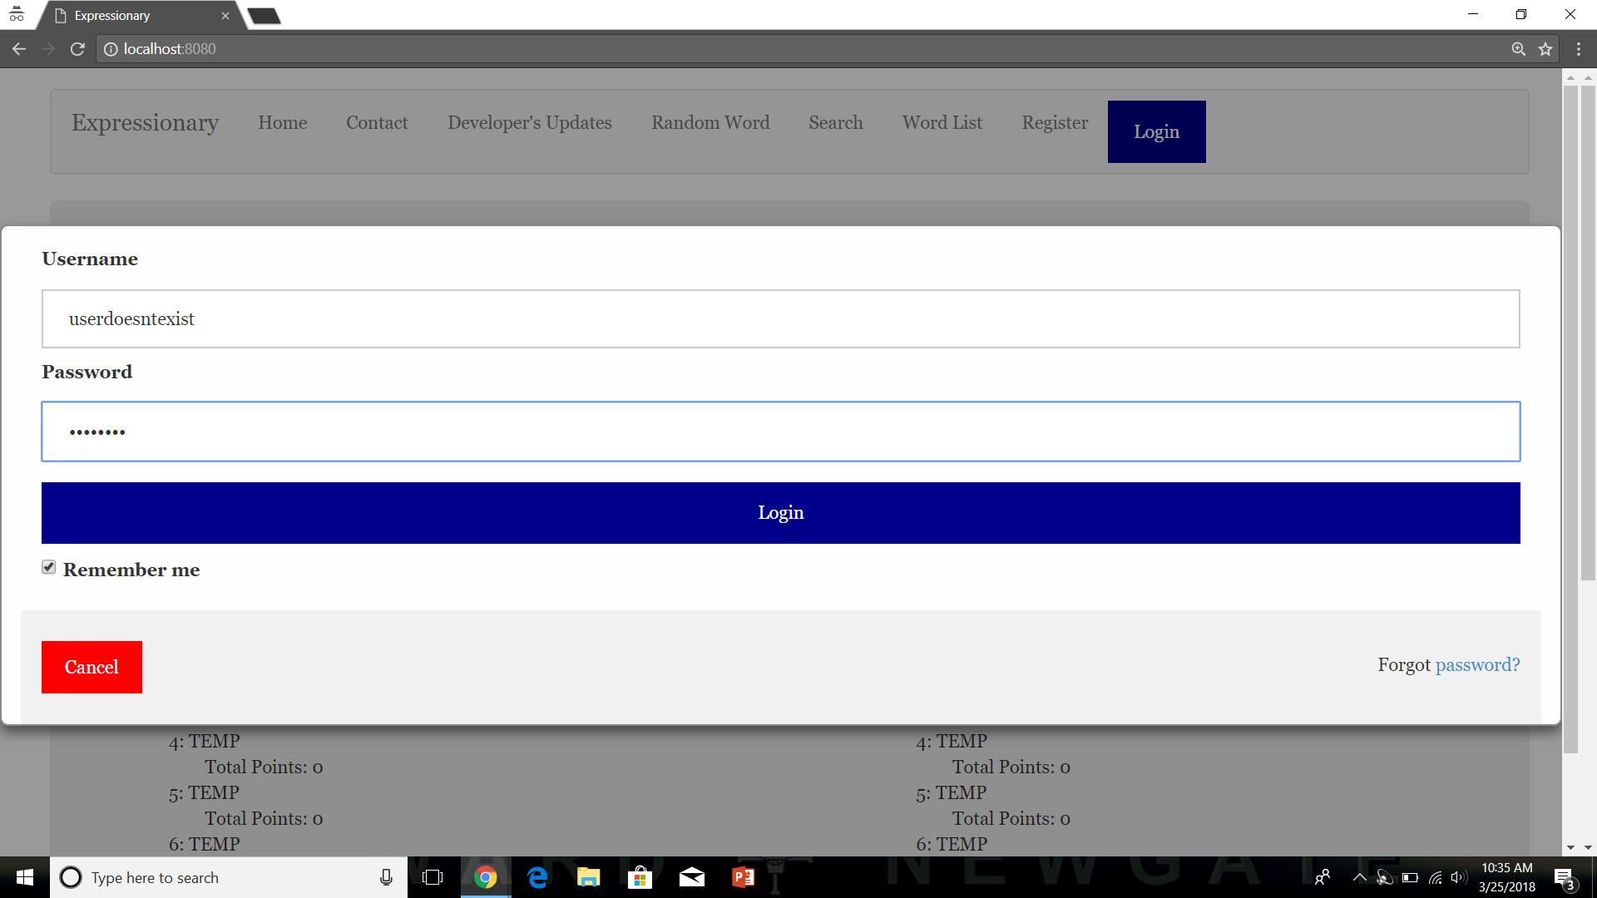

Press Login

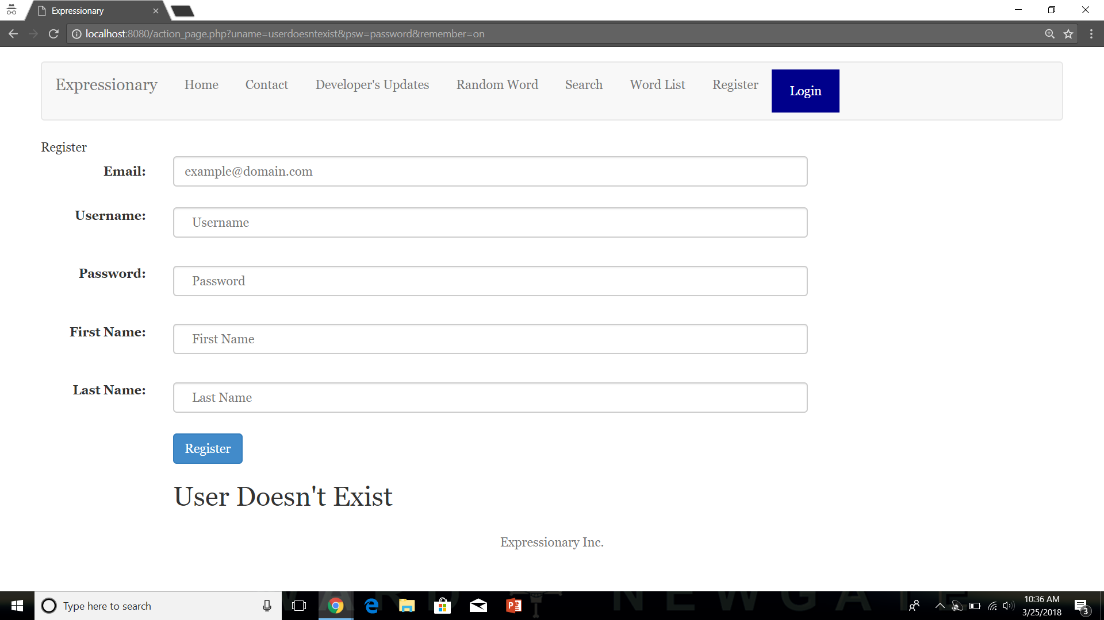

**Results:**

Since the user is not registered a message is shown saying that the user doesn’t exist, hence non-registered user cannot log in

**Test No.6**

Entering the wrong password will tell the user that their credentials are not valid

**Procedure:**

* Enter a valid username but wrong password
* Validate the response
* Report the behavior

**Test**

Navigate to the home page

Provide login with correct username but wrong password

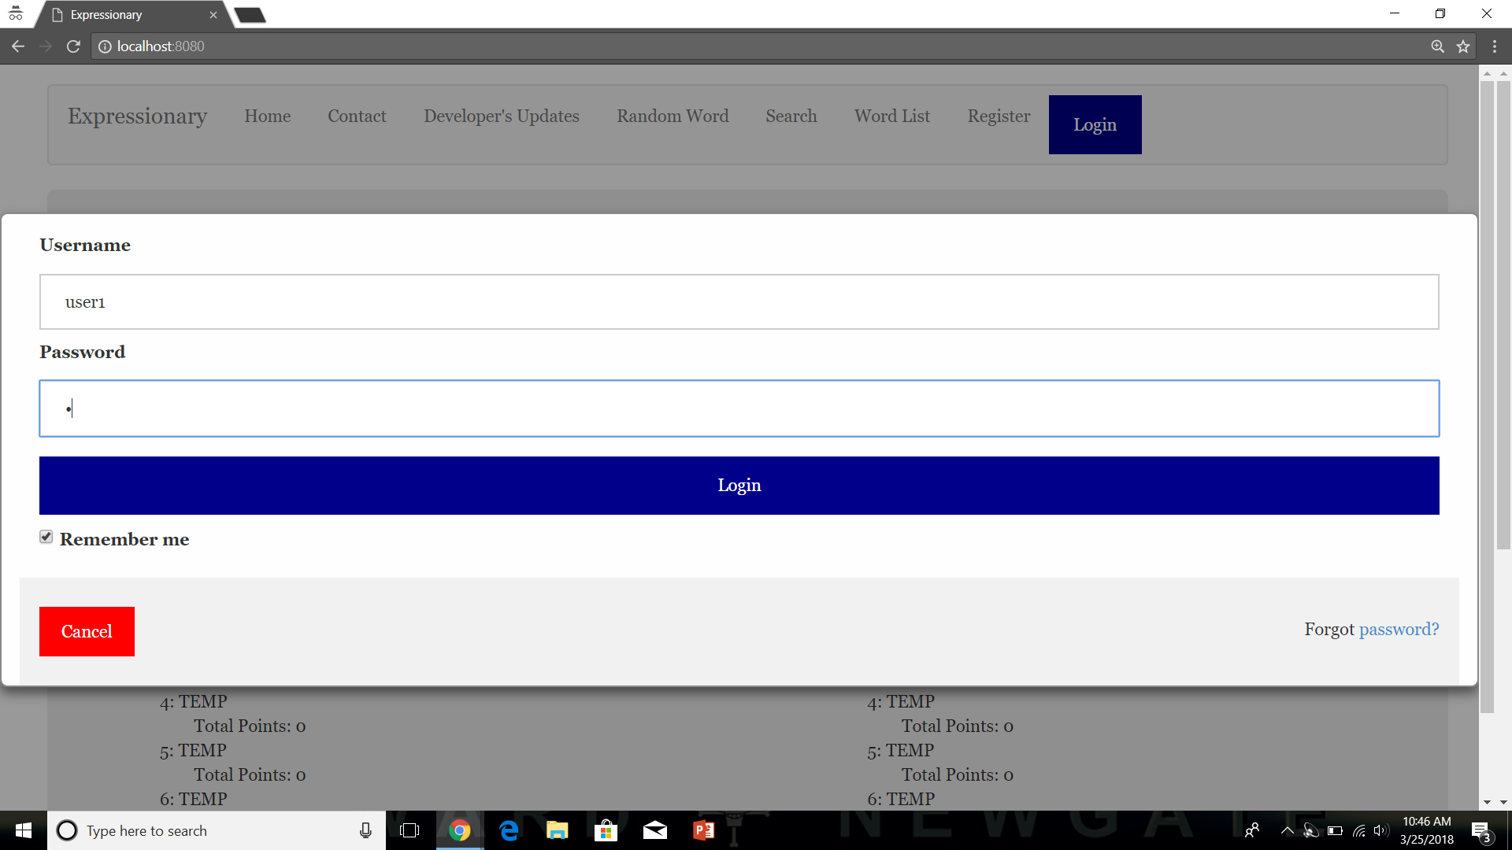

Press Login and record the response

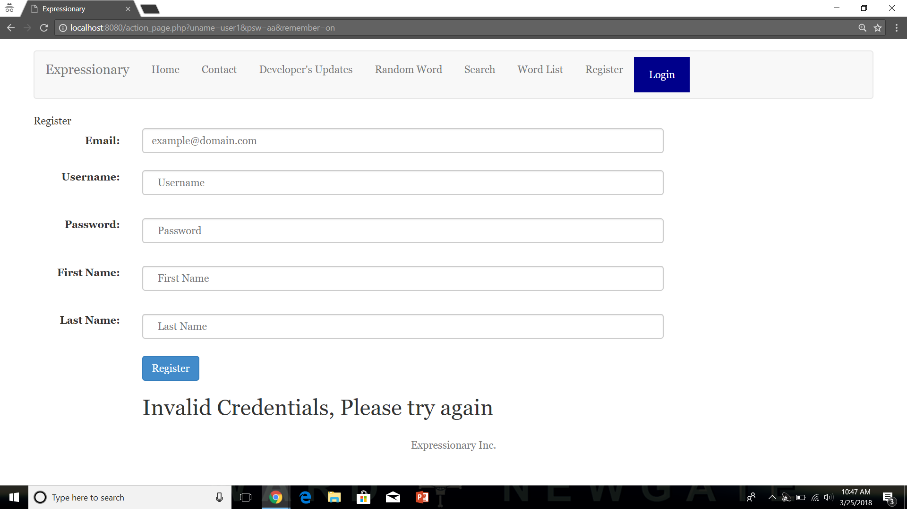

**Results:**

The program responds with invalid credentials for wrong password which is what we expected.

**USER STORY #5**

**Test No.1**

Personal User Page does not show up if the user is not logged in

**Procedure:**

* Navigate to the home page
* Check if a user button is visible or login button
* Check in the header
* Report the response

**Test**

Navigate to the home page

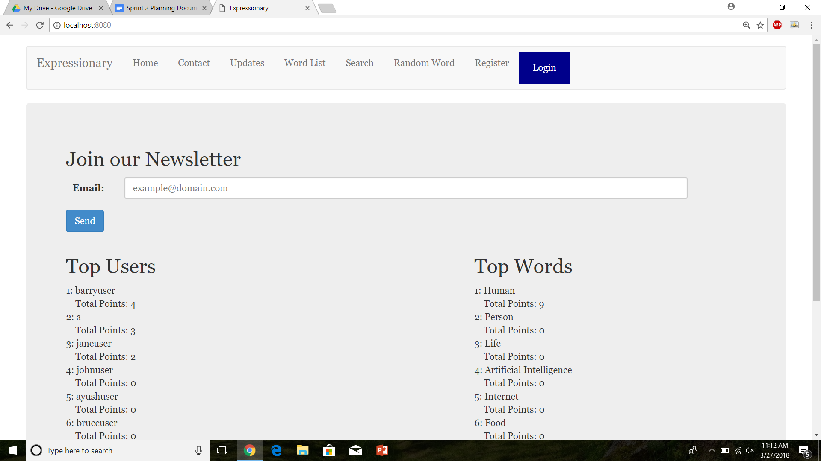

Check the Header



Report the response.

**Results:**

Since there is login button and register button, a personal user page button is not visible which is what we were expecting.

**Test No.2**

Navigating to a different page does not change the header and does not show any other responses

**Procedure:**

* Navigate to the home page
* Check if a user button is visible or login button
* Navigate to another page
* Check in the header
* Report the response

**Test**

Navigate to the home page



Check the Header



Navigate to another page

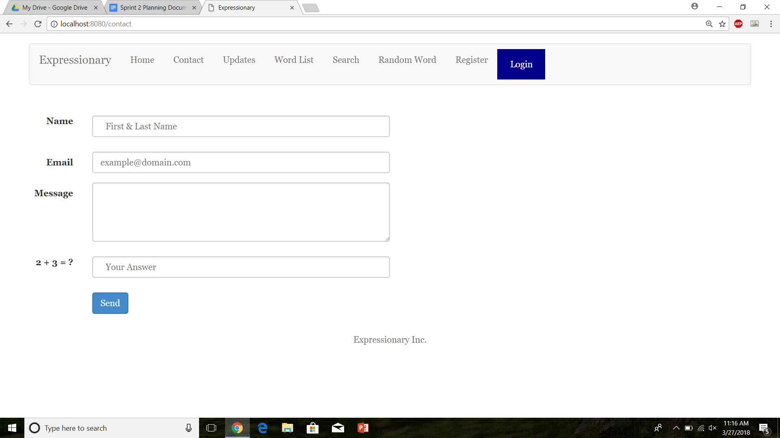

Report the response

**Results:**

Since there is login button and register button, a personal user page button is not visible even on other pages which is what we were expecting.

**Test No.3**

Navigating to a different page multiple times back and forth does not change the header and does not show any other responses

**Procedure:**

* Navigate to the home page
* Check if a user button is visible or login button
* Navigate to another page
* Check in the header
* Report the response
* Repeat

**Test**

Navigate to the home page



Check the Header



Navigate to another page

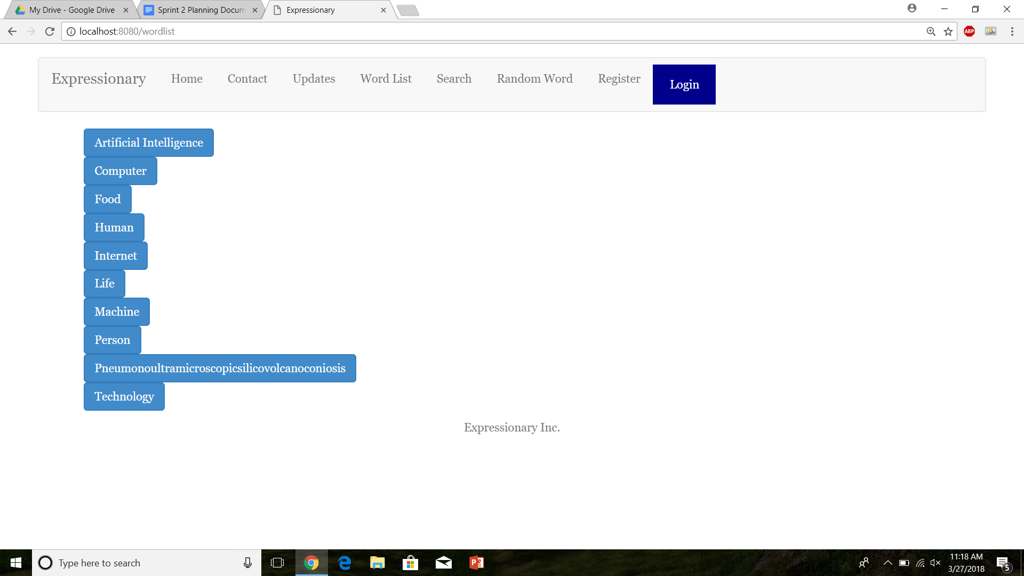

Report the response

Navigate to another page

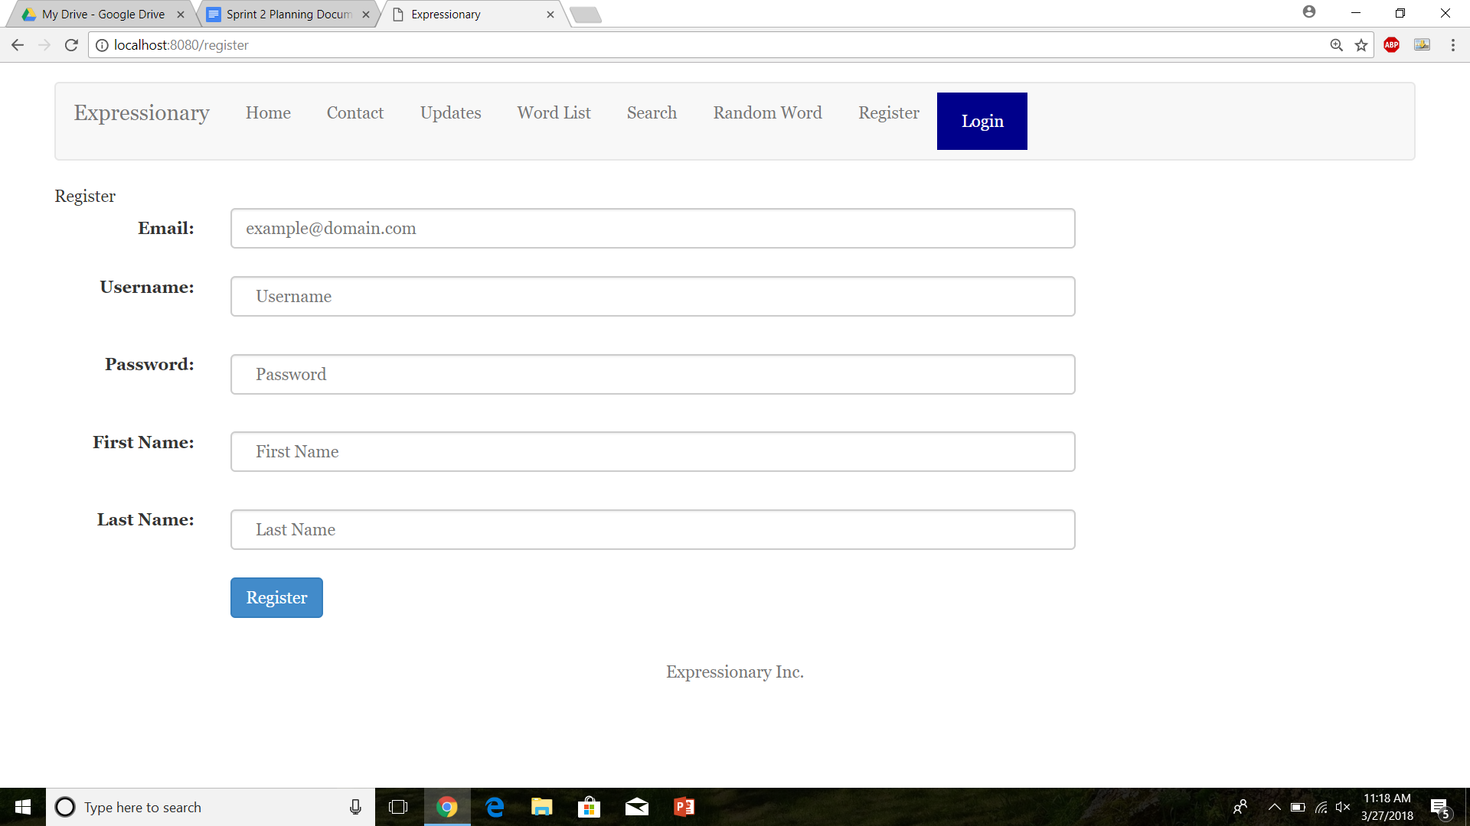

Navigate to another page

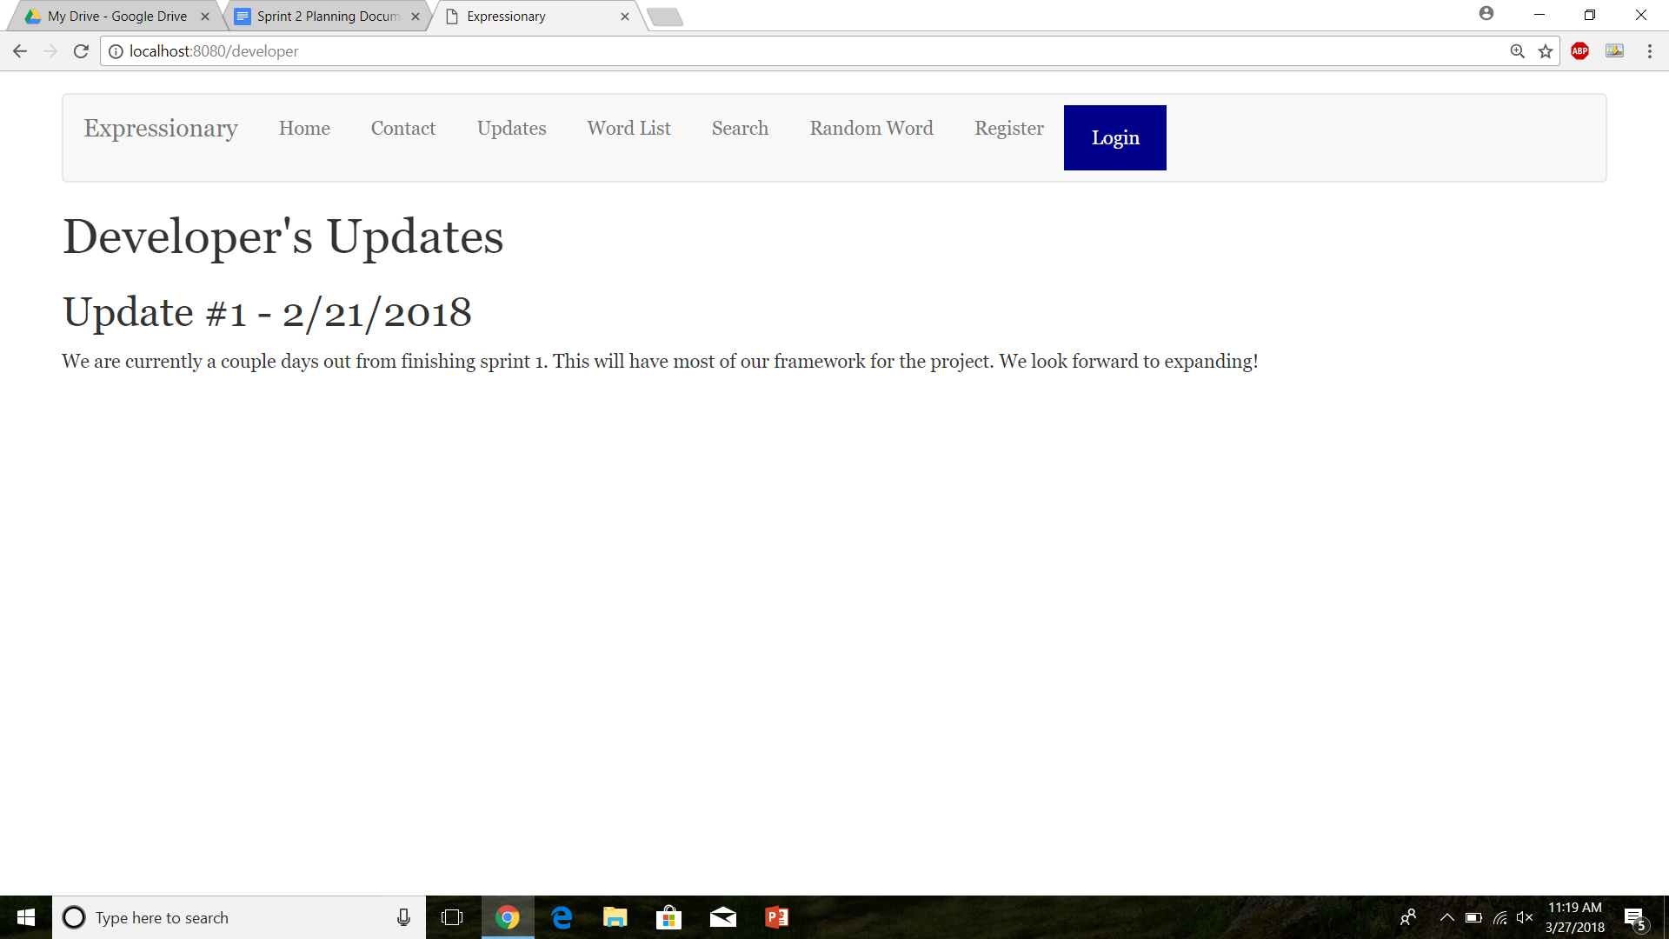

Report the response

Note: This test was done more times then this, all data is not being shown to be space efficient.

**Results:**

Robustness test: Since there is login button and register button, a personal user page button is not visible even on other pages after multiple tries which is what we were expecting.

**Test No.4**

After Logging in, the register button and Login button changes to Logout and profile button

**Procedure:**

* Navigate to the home page
* Login with valid credentials
* Check the header
* Report the response

**Test**

Navigate to the home page



Login with valid credentials

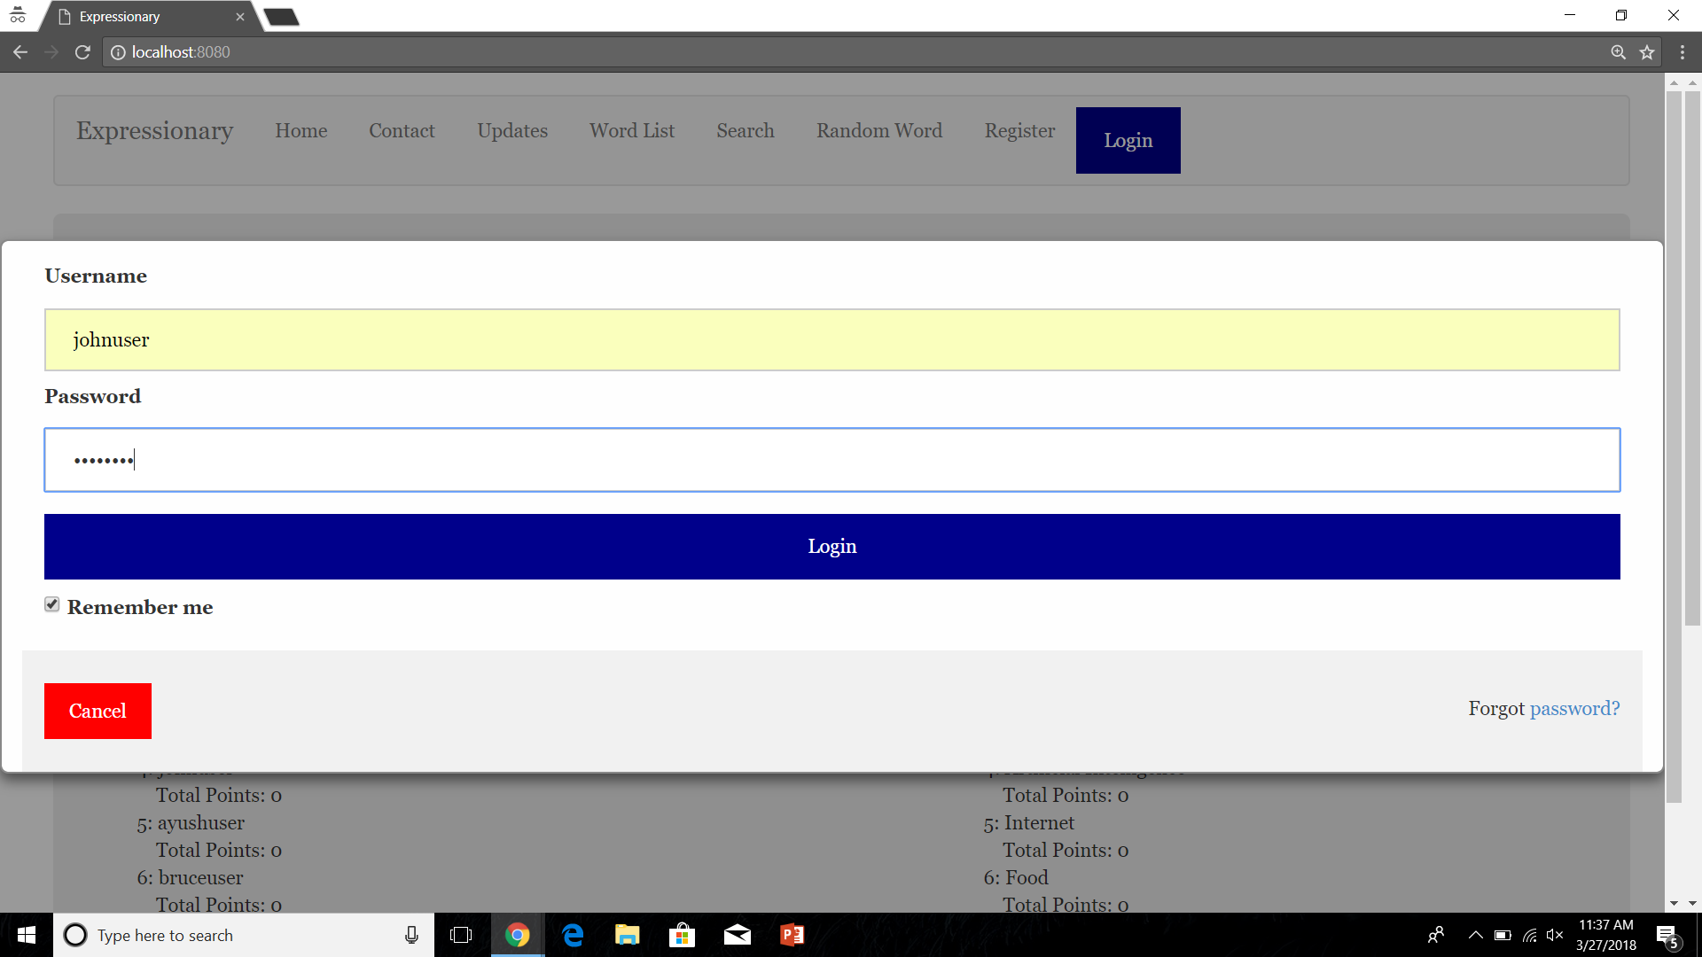

Check the header

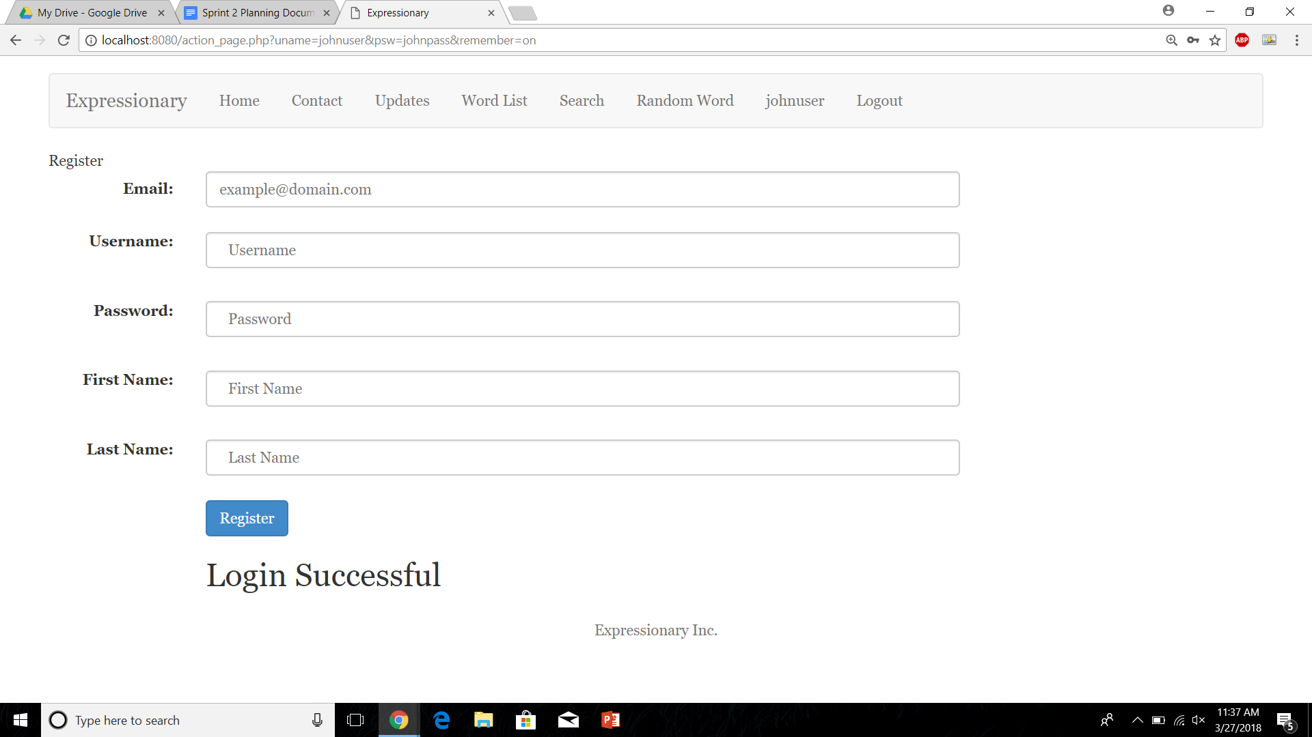

Report the response

**Results:**

After Logging in the login and register buttons change to username and logout.

**Test No.5**

Check to see if the username leads to the correct user page

**Procedure:**

* Navigate to the home page
* Login with valid credentials
* Click on the username button in the header
* Report the response

**Test**



Click on the user button

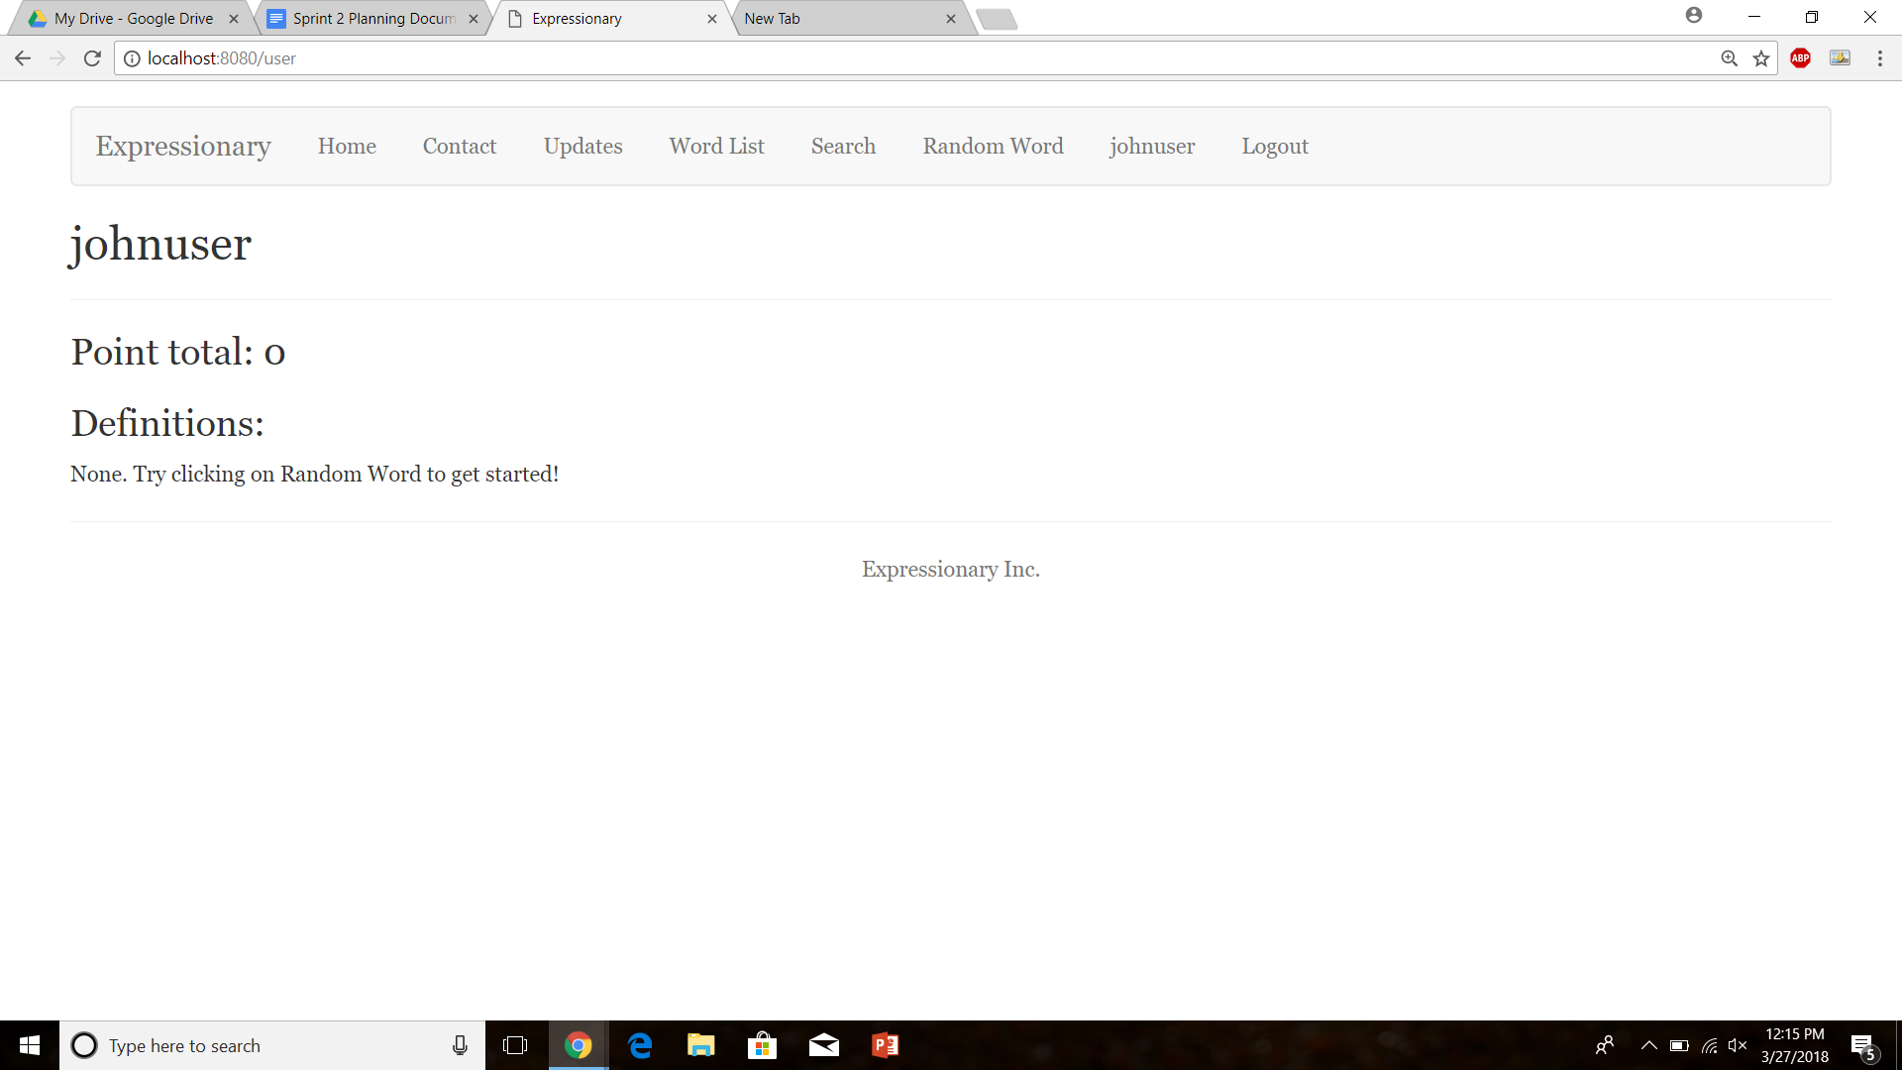

**Results:**

The user button leads to the profile page of the correct user.

**Test No.6**

Check to see if the username leads to the correct user page on multiple tries, Robustness test

**Procedure:**

* Navigate to the home page
* Login with valid credentials
* Click on the username button in the header
* Navigate to a different page
* Click on the user button again
* Report the response
* Repeat

**Test**



Click on the user button



Navigate to a different page

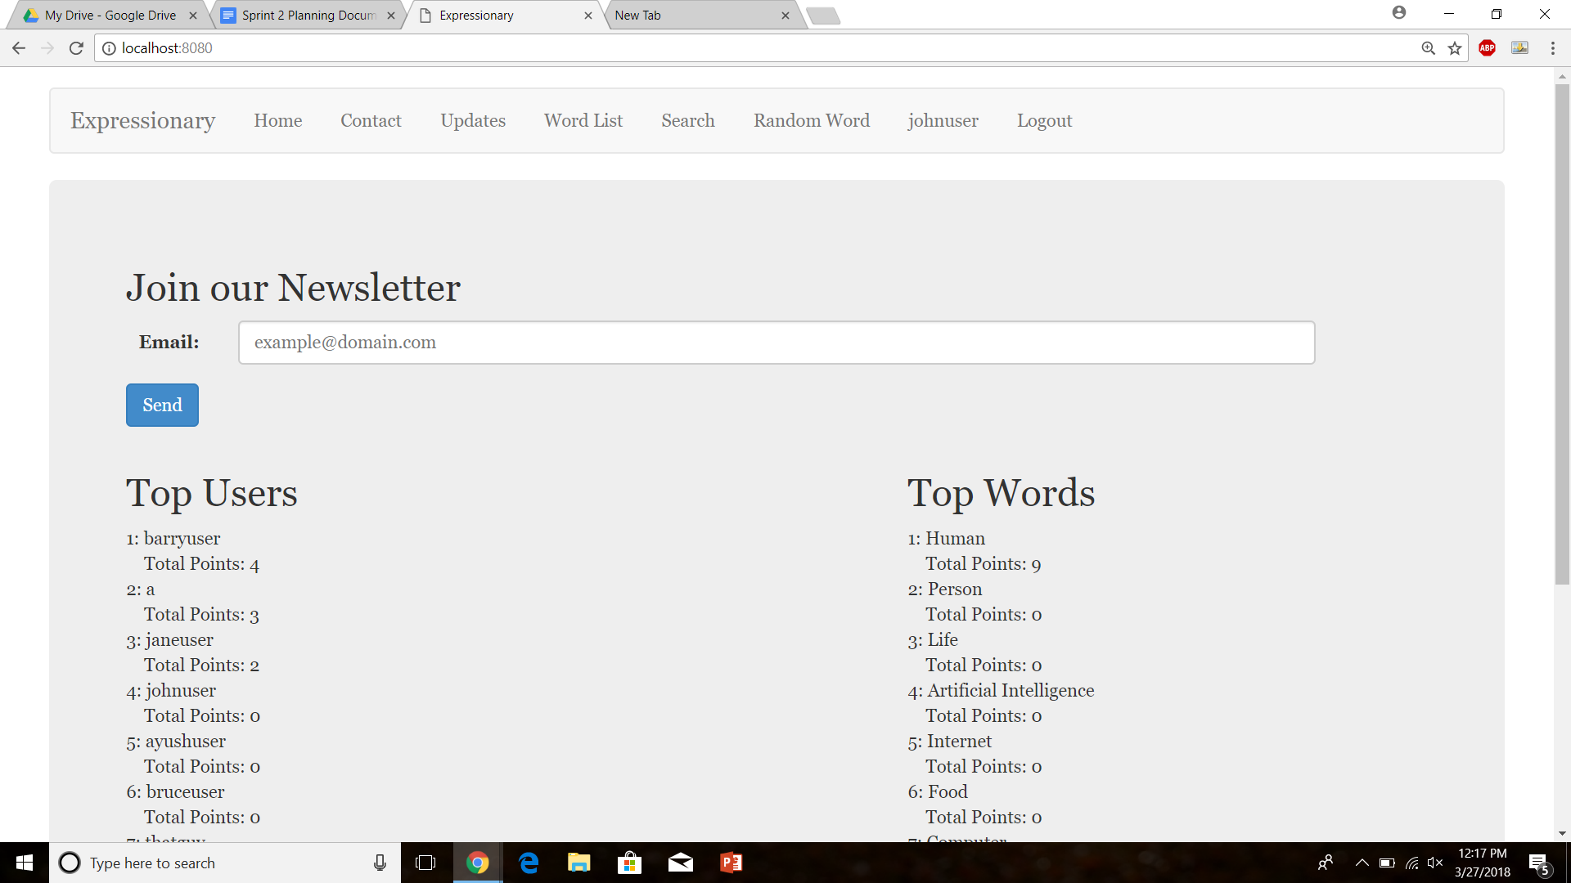

Navigate to User Page

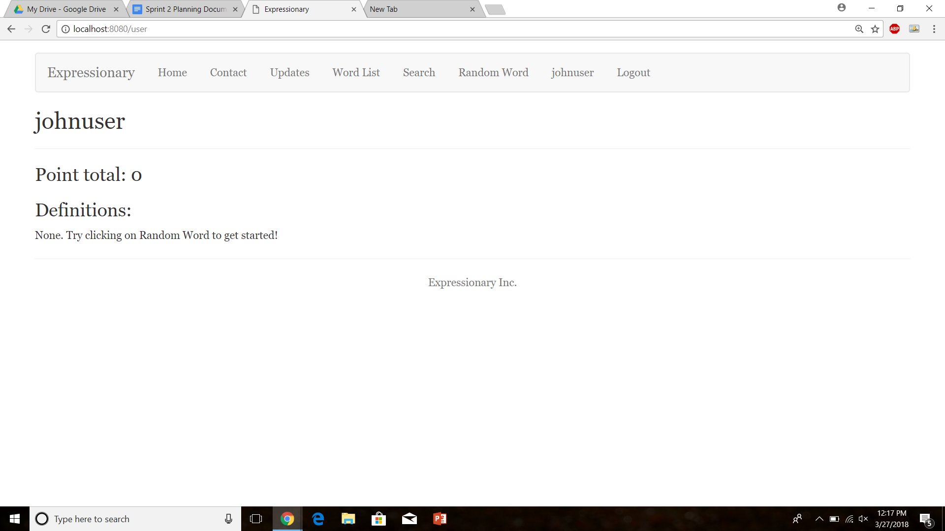

Navigate to a different page

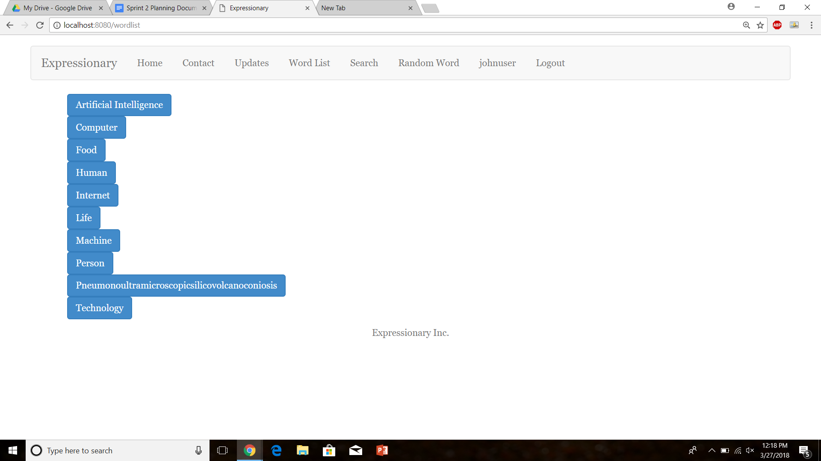

Navigate to user Page



**Results:**

The user button leads to the profile page of the correct user. On multiple tries and the program does not break, this is correct and expected behavior.

**Test No.7**

Check to see if the same user page can be navigated to through searching the user

**Procedure:**

* Navigate to the search page
* Type the name of the user to search
* Click on User option and press Search
* Report the Response

**Test**

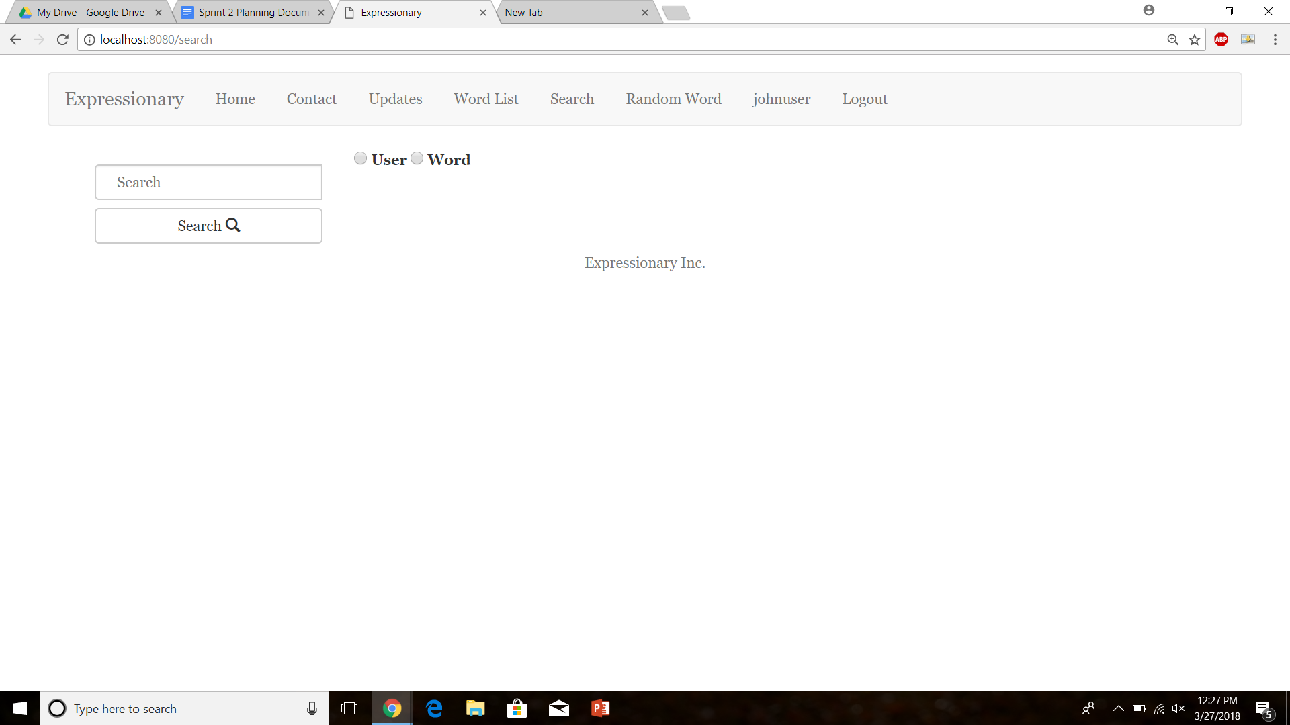

Search the user using appropriate steps

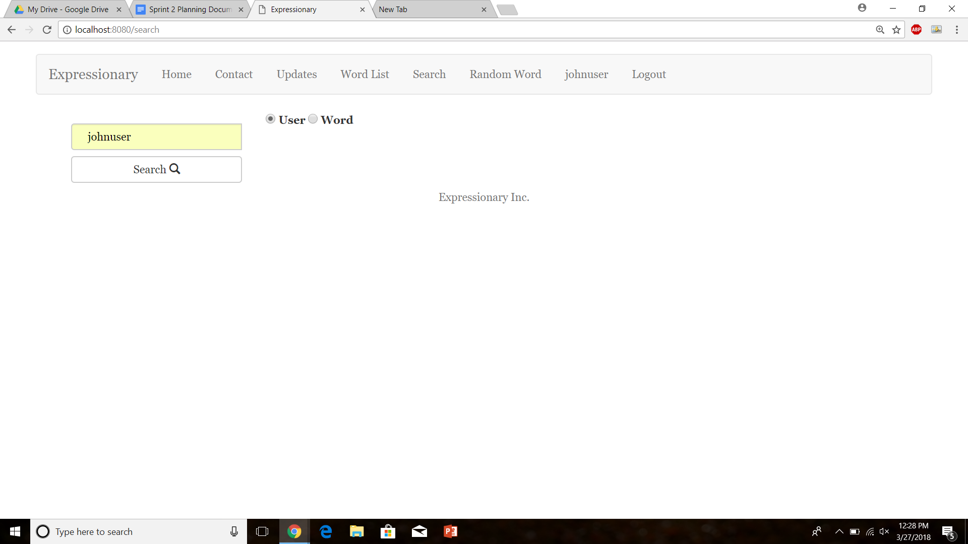

Press Search

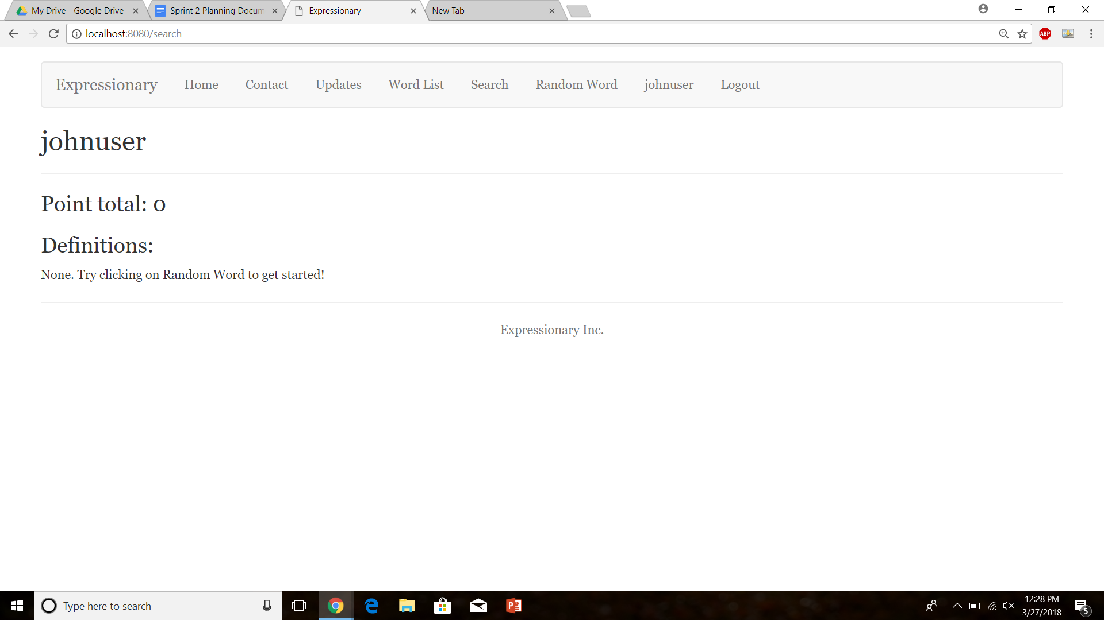

**Results:**

The same user page can be found by using the search feature.

**Test No.8**

Test to check if any user page can be found using search and not just the logged in user

**Procedure:**

* Navigate to the search page
* Type in a user’s name other than the logged in user
* Fill appropriate fields and Press Search
* Report the result
* Repeat

**Test**

Type in a user other than the logged in user

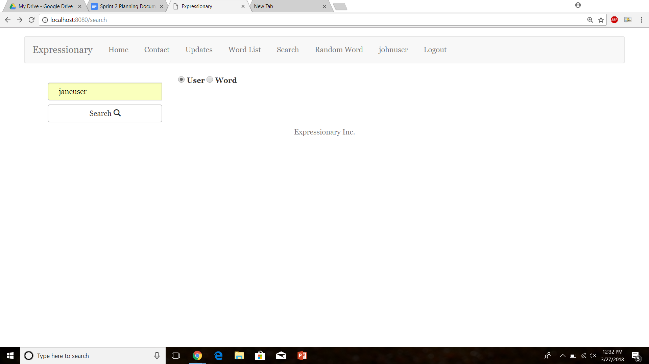

Press Search

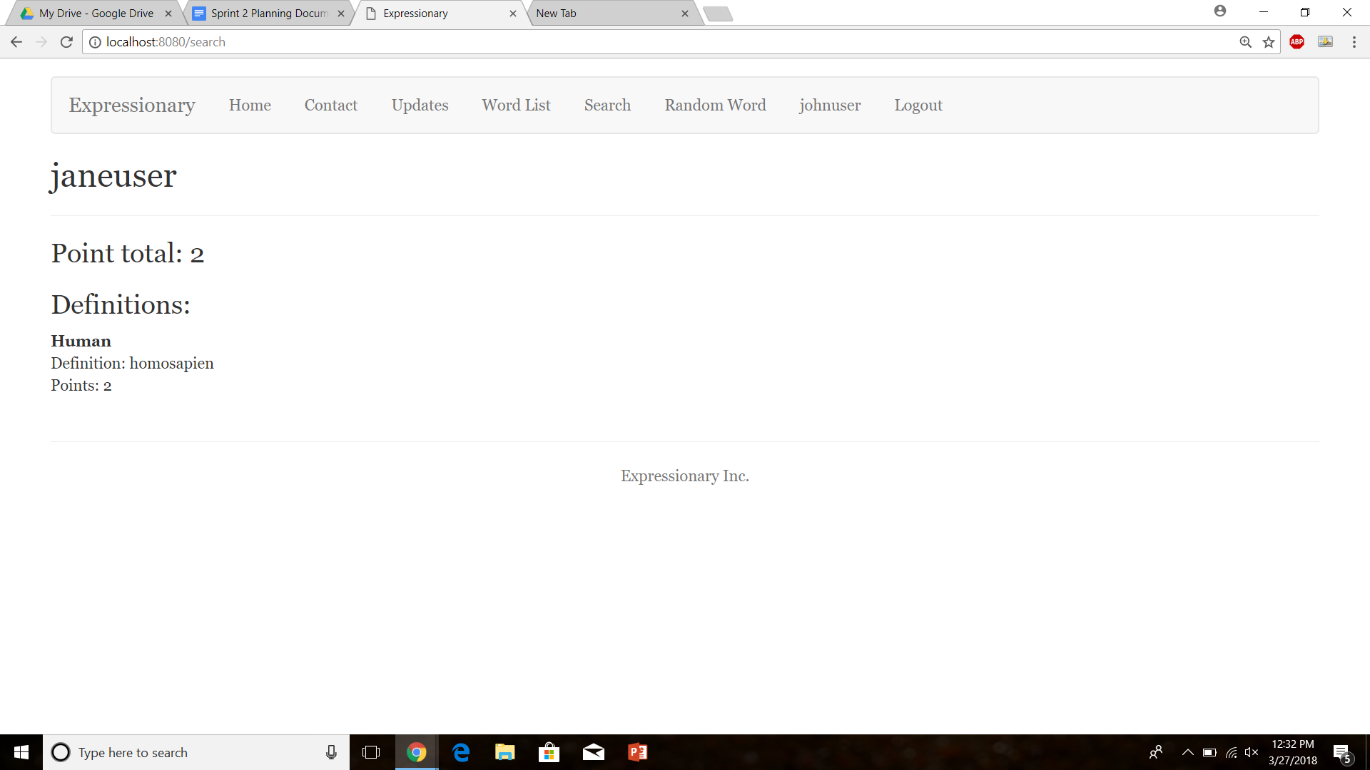

Repeat the Same process

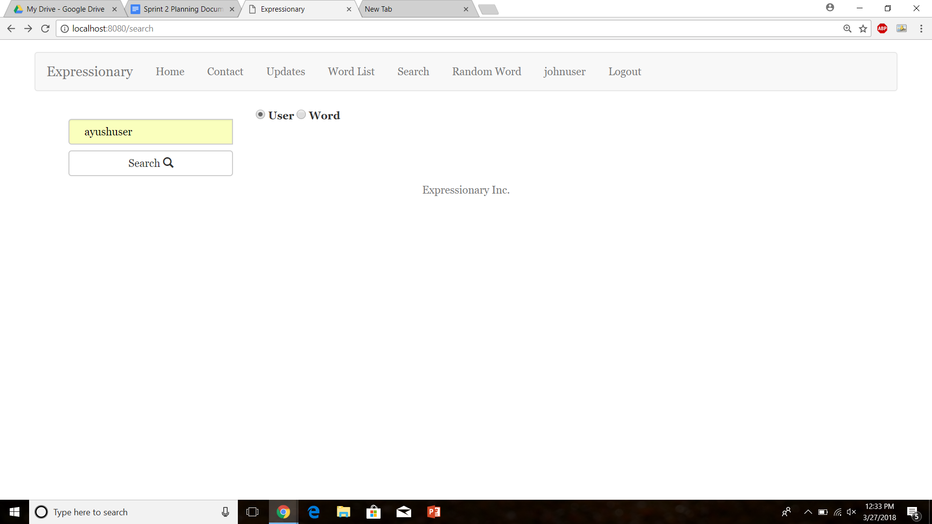

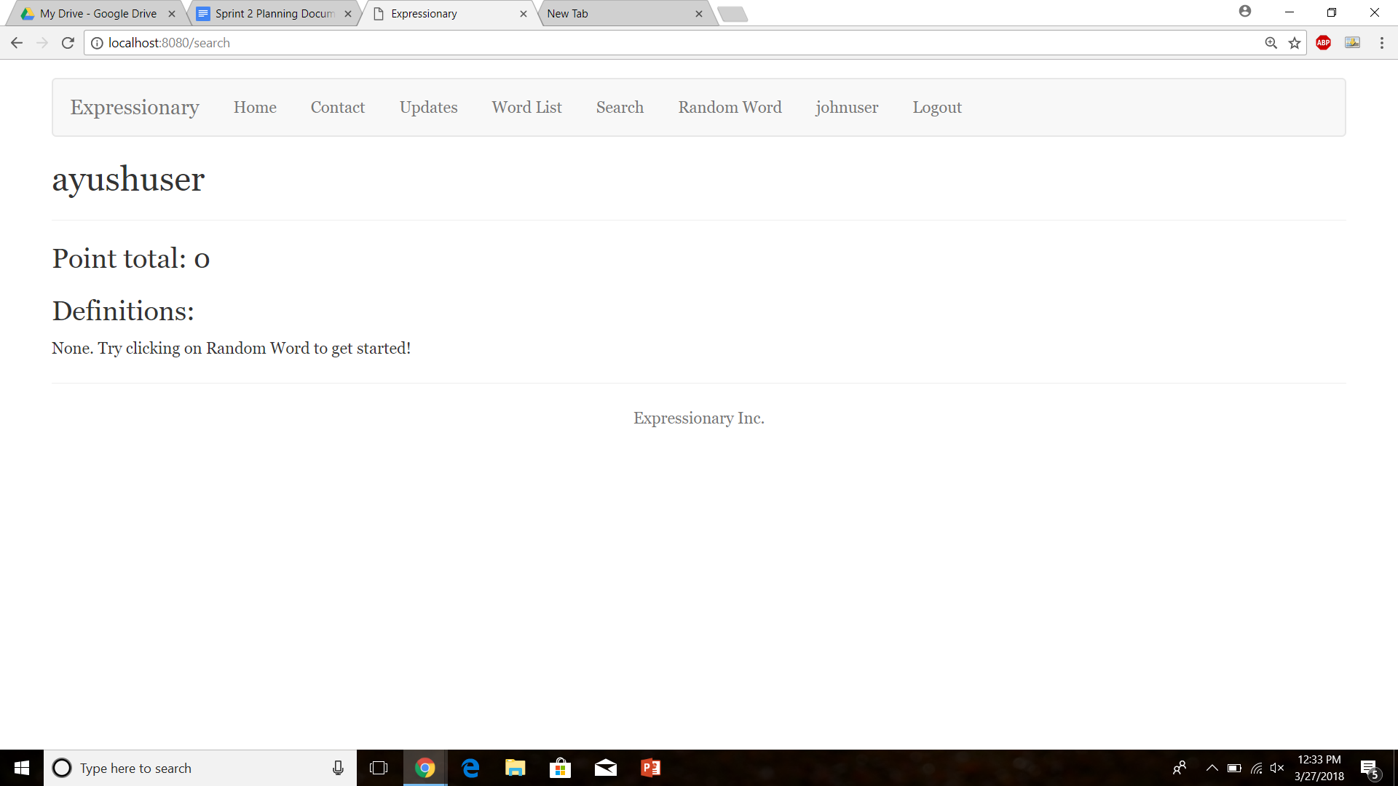

Report the results

**Results:**

Program works as expected, any user can be searched and not just the logged in users.

**Test No.9**

Check to see if the users can be searched and led to the user page even if the user is not logged in.

**Procedure:**

* Navigate to the home page
* Search for a user without logging in
* Report the response

**Test**

Navigate to search page without logging in

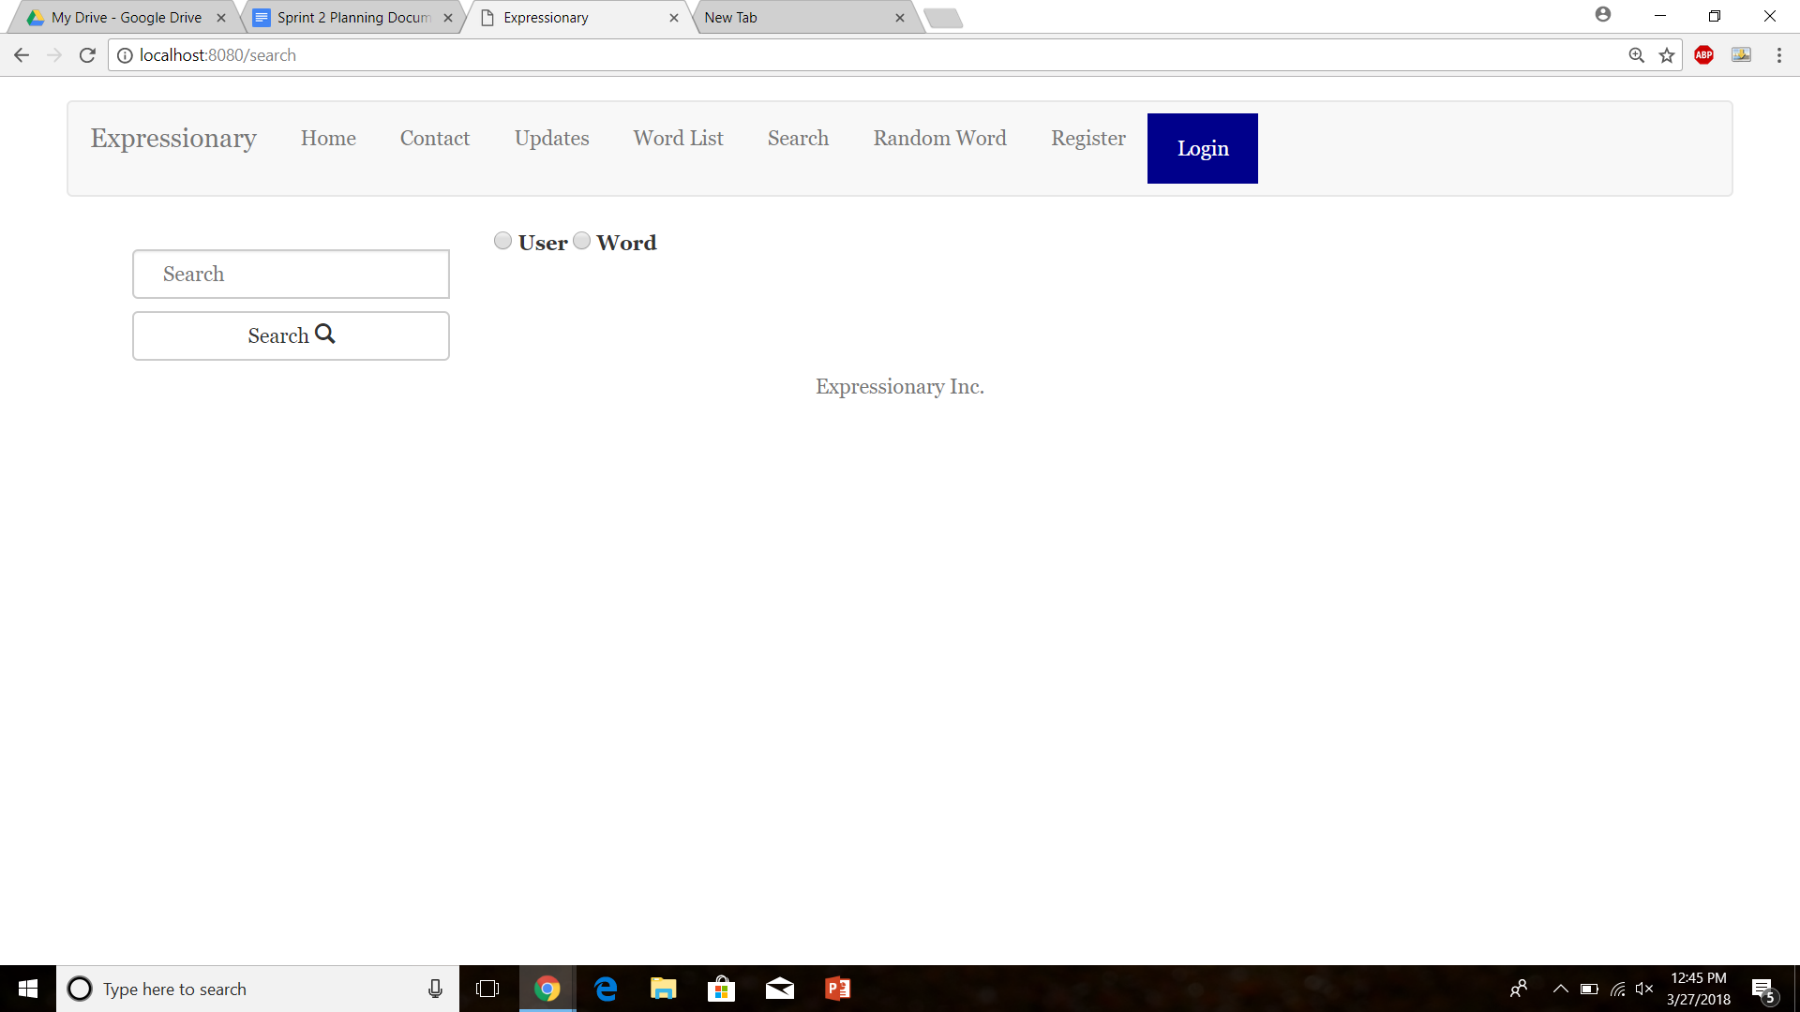

Search for a valid user

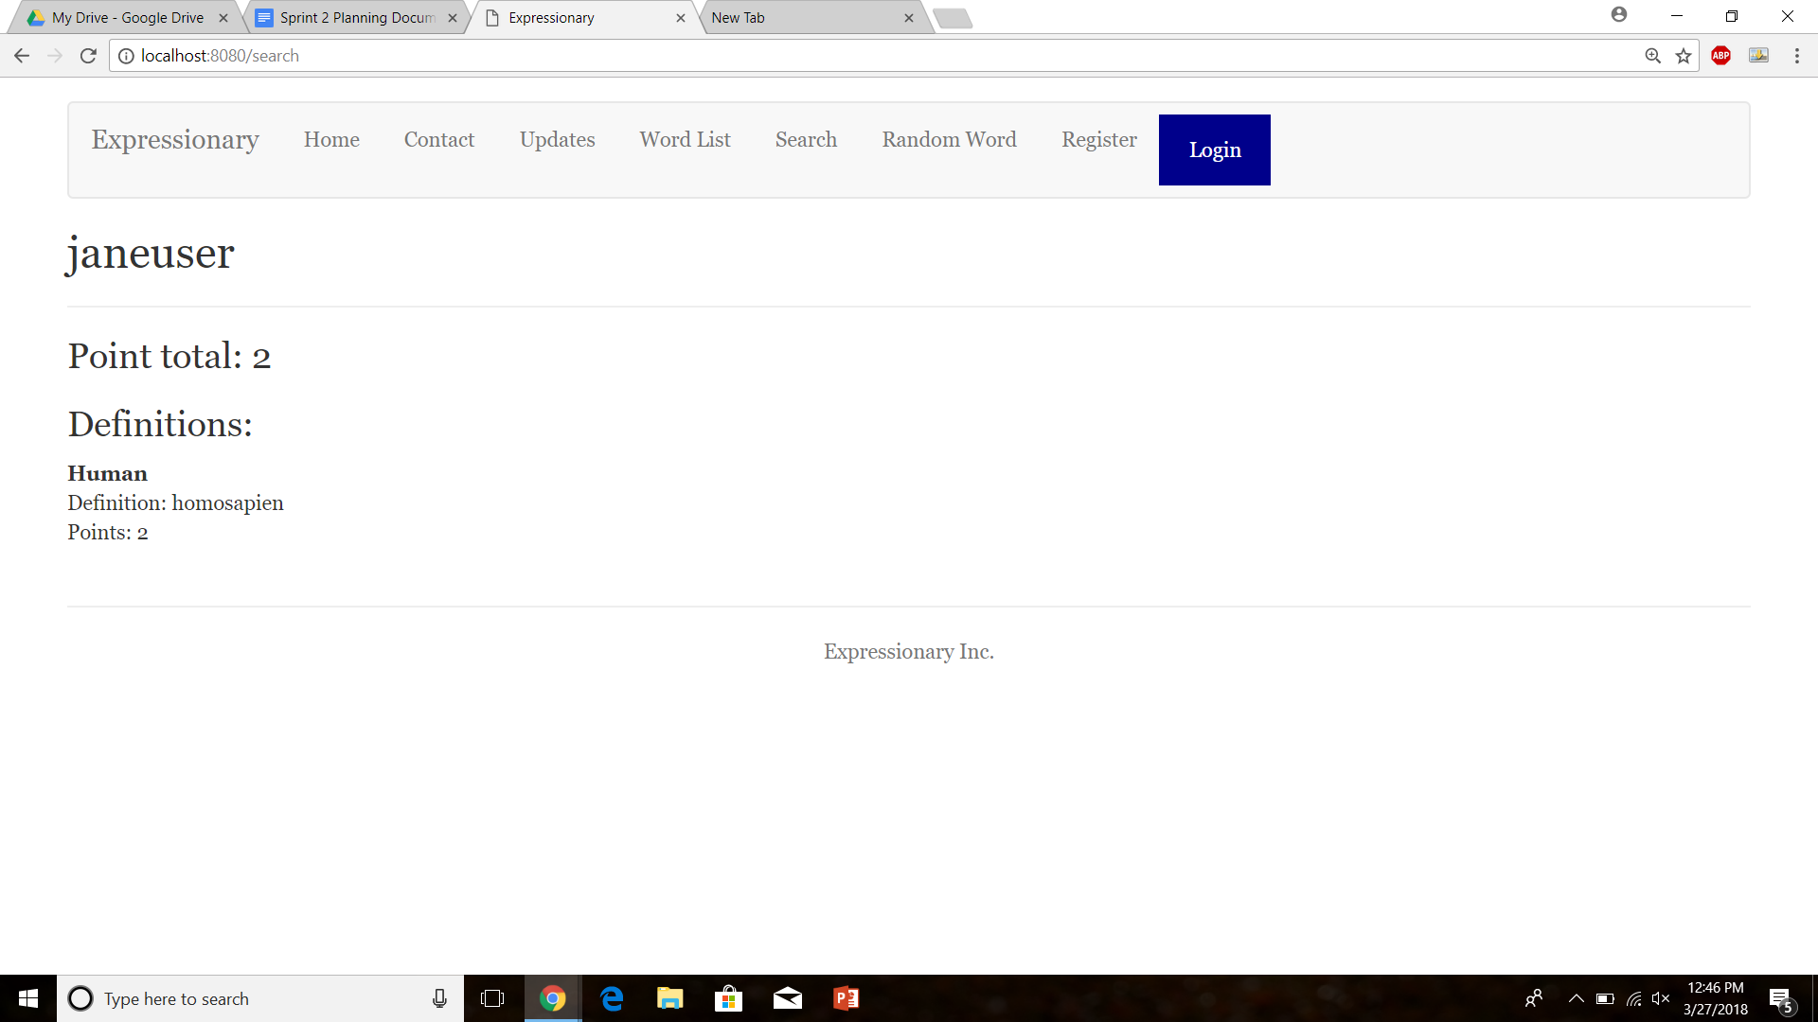

**Results:**

The user button leads to the profile page of the correct user even if the user is not logged in.

**Test No.10**

Test to check if the user page displays the point total

**Procedure:**

* Navigate to the home page
* Login with valid credentials
* Click on the username button in the header
* Check the user page
* Report the response

**Test**

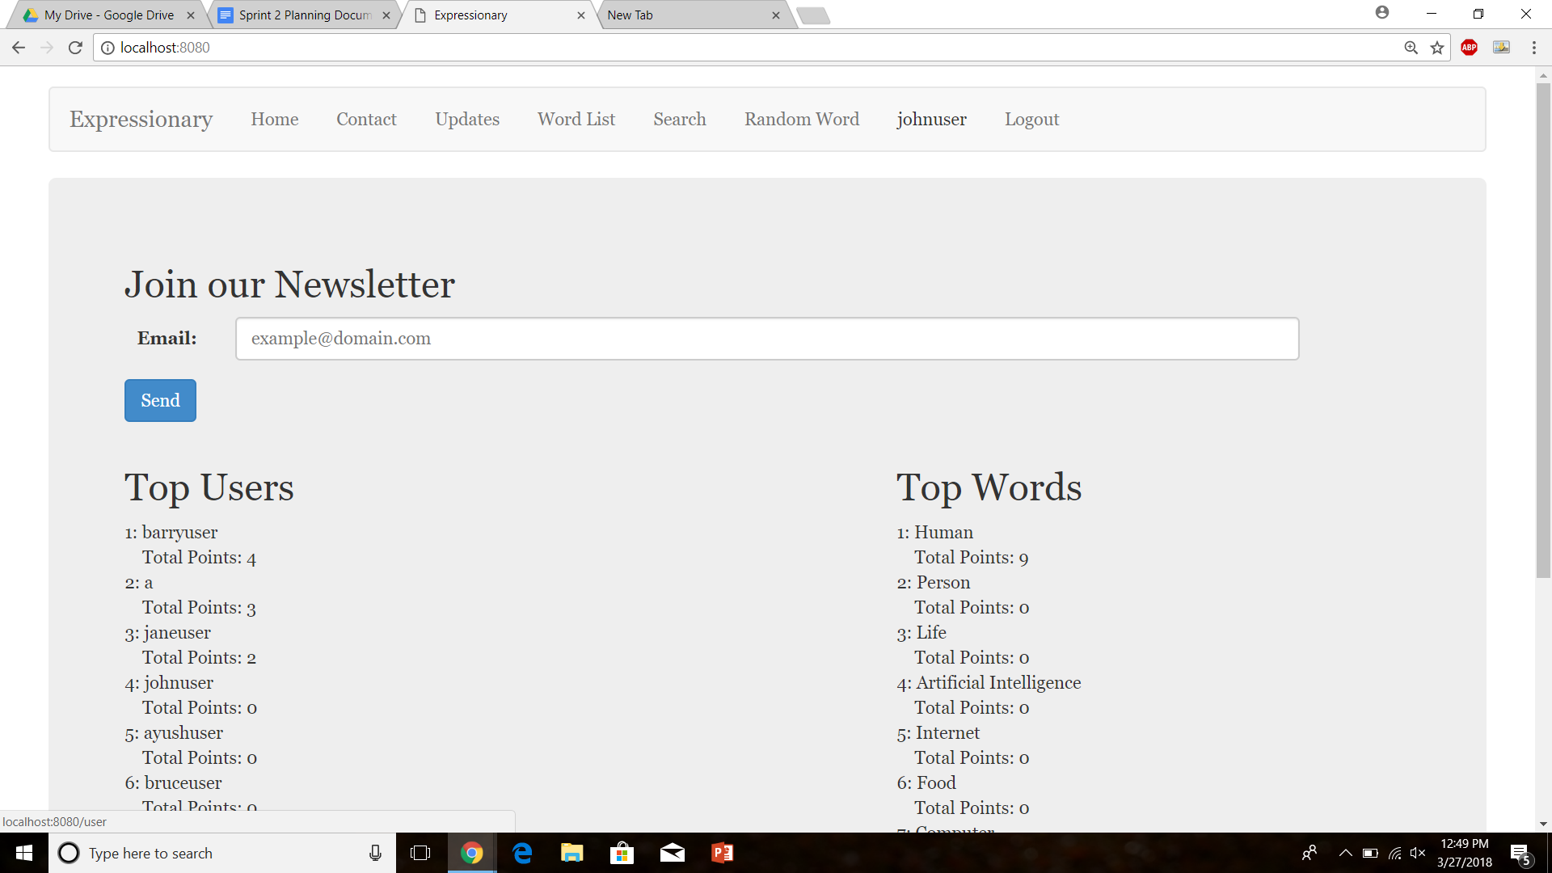

Click on the user button

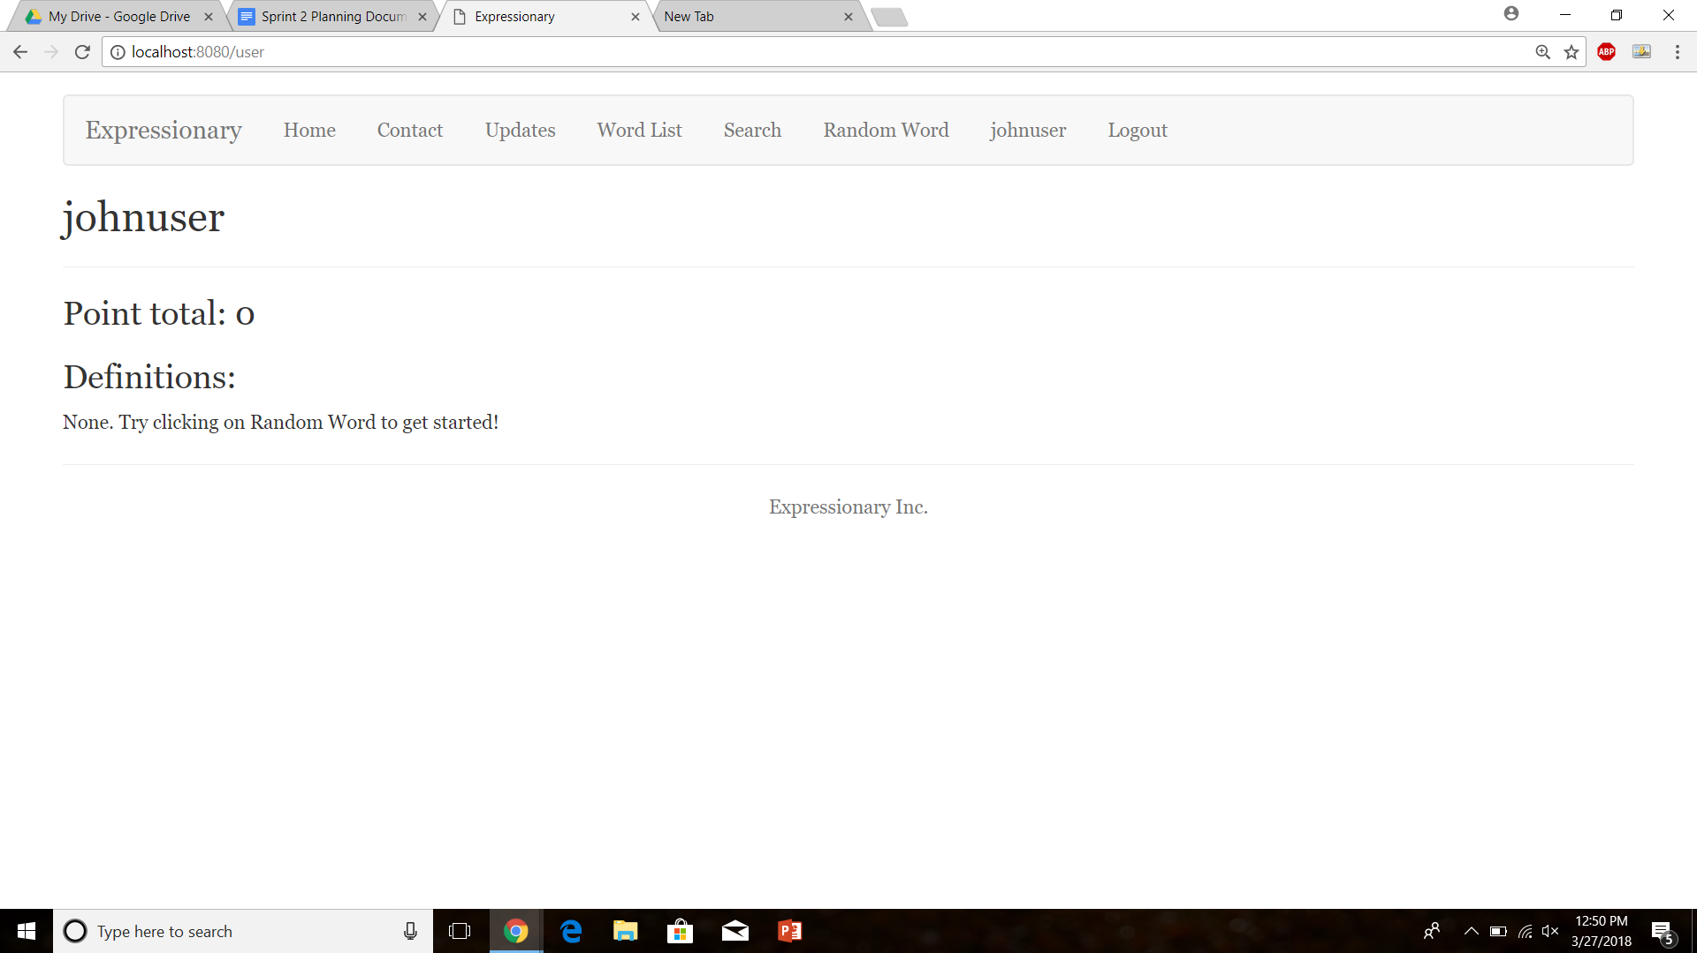

**Results:**

The user button leads to the profile page of the correct user and the point total is displayed correctly.

**Test No.11**

Check to see if the point total on the user page get decremented properly

**Procedure:**

* Navigate to the home page
* Login with valid credentials
* Find a definition posted by the logged in user
* Subtract a point from your own definition
* Navigate to the user page
* Report the response

**Test**

Navigate to the user page

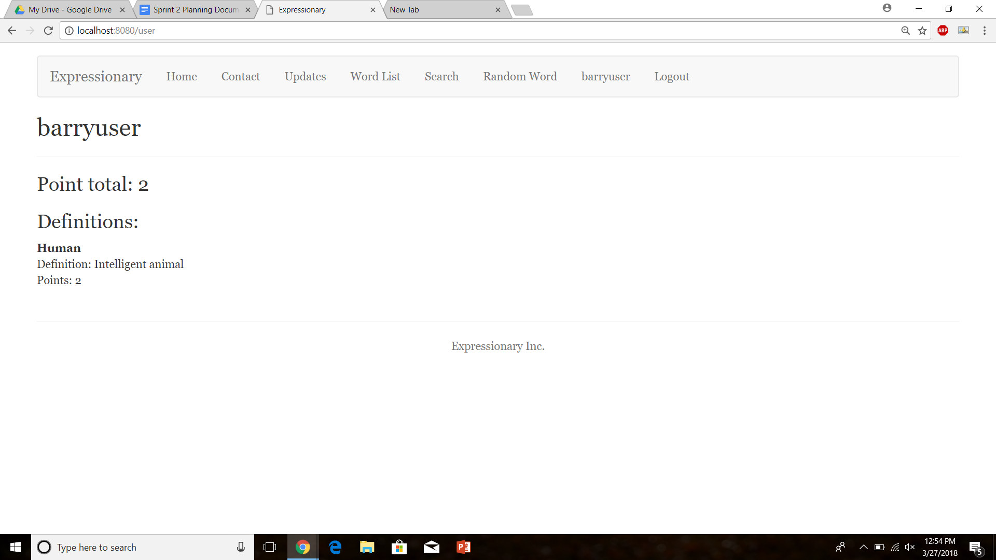

Go to the definitions posted by the user

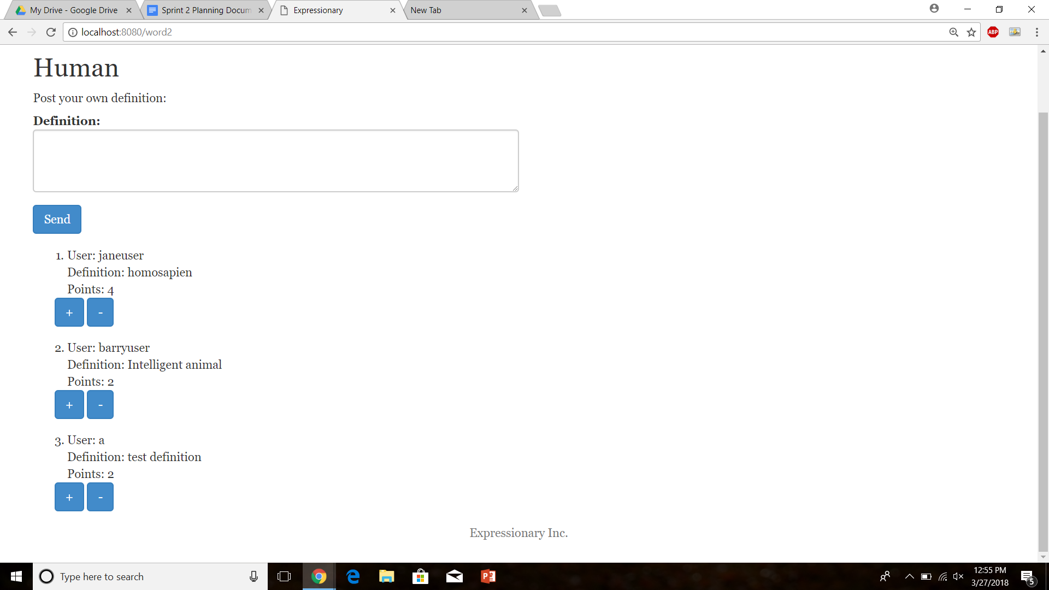

Decrement a point

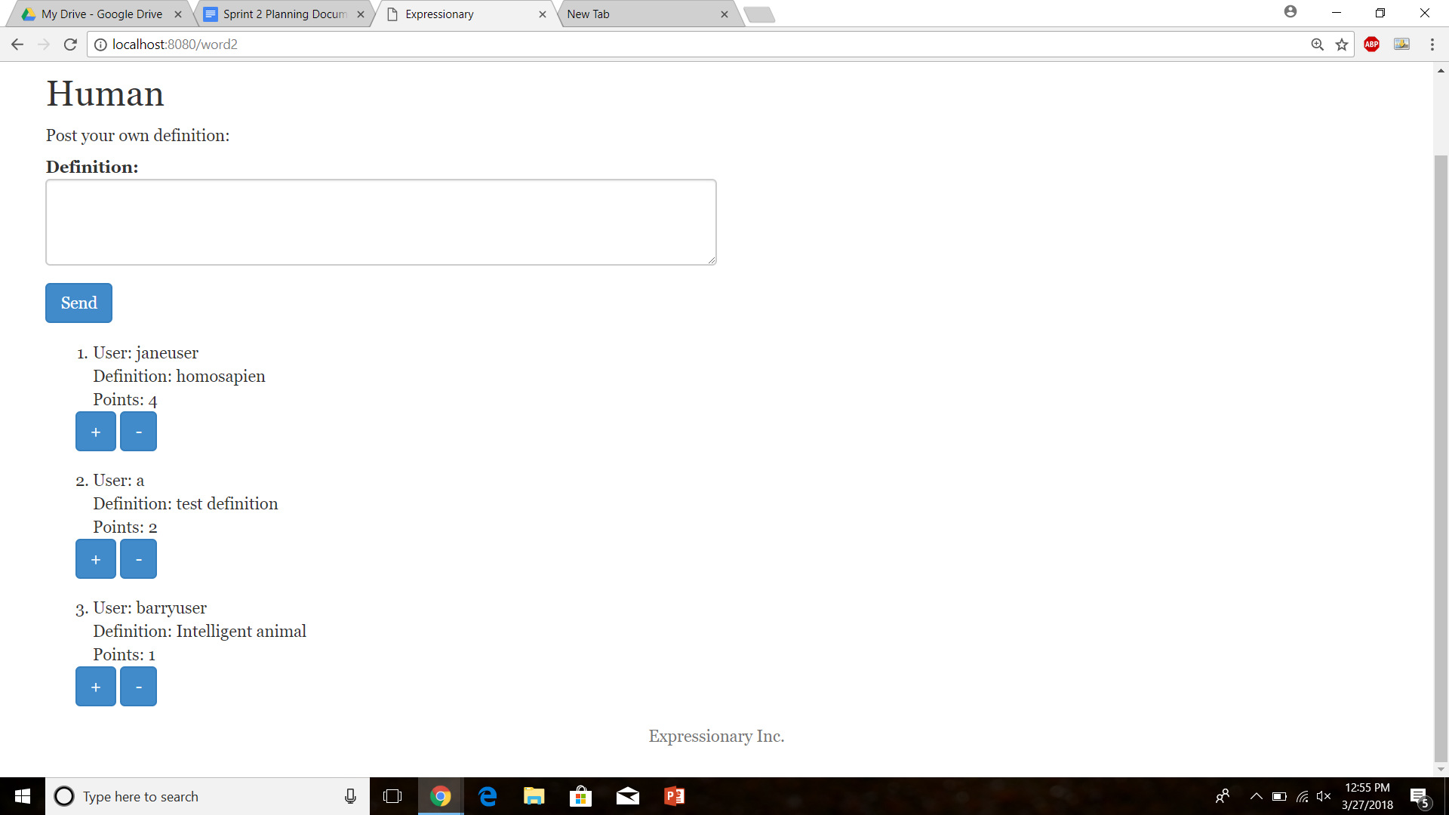

Check the user page

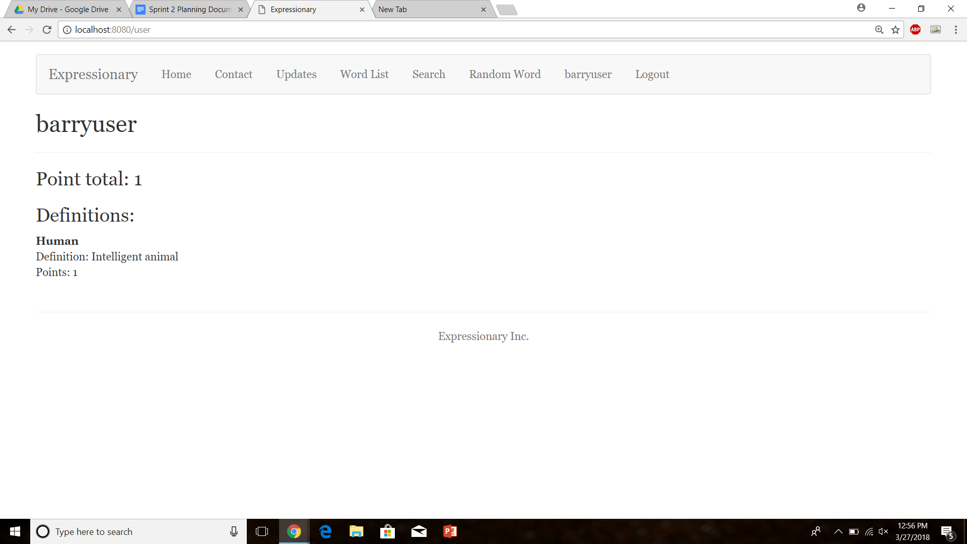

**Results:**

Expected Results. The point total changes as the points to a user change.

**Test No.12**

Test to check If points are being incremented in the point total

**Procedure:**

* Navigate to the home page
* Login with valid credentials
* Find a definition posted by the logged in user
* Add a point to your own definition
* Navigate to the user page
* Report the response

**Test**

Navigate to user page



Find a definition by the user



Increment a point



Navigate back to the user page



Report the result

**Results:**

Expected Results. The point total changes as the points to a user change.

**Test No.13**

Check to see if the user page displays the definitions from the correct user

**Procedure:**

* Login with valid credentials
* Navigate to the user page
* Click on the username button in the header
* Report the response on the user page

**Test**

Log in with a valid user



Click on the user button



**Results:**

The user page displays the correct definitions associated with the user.

**Test No.14**

Test to check if new definitions added are reflected on the user page.

**Procedure:**

* Login with valid credentials
* Add a definition to a word
* Navigate to the user page
* Report the response

**Test**

Navigate to the user page



Add a new definition to a word

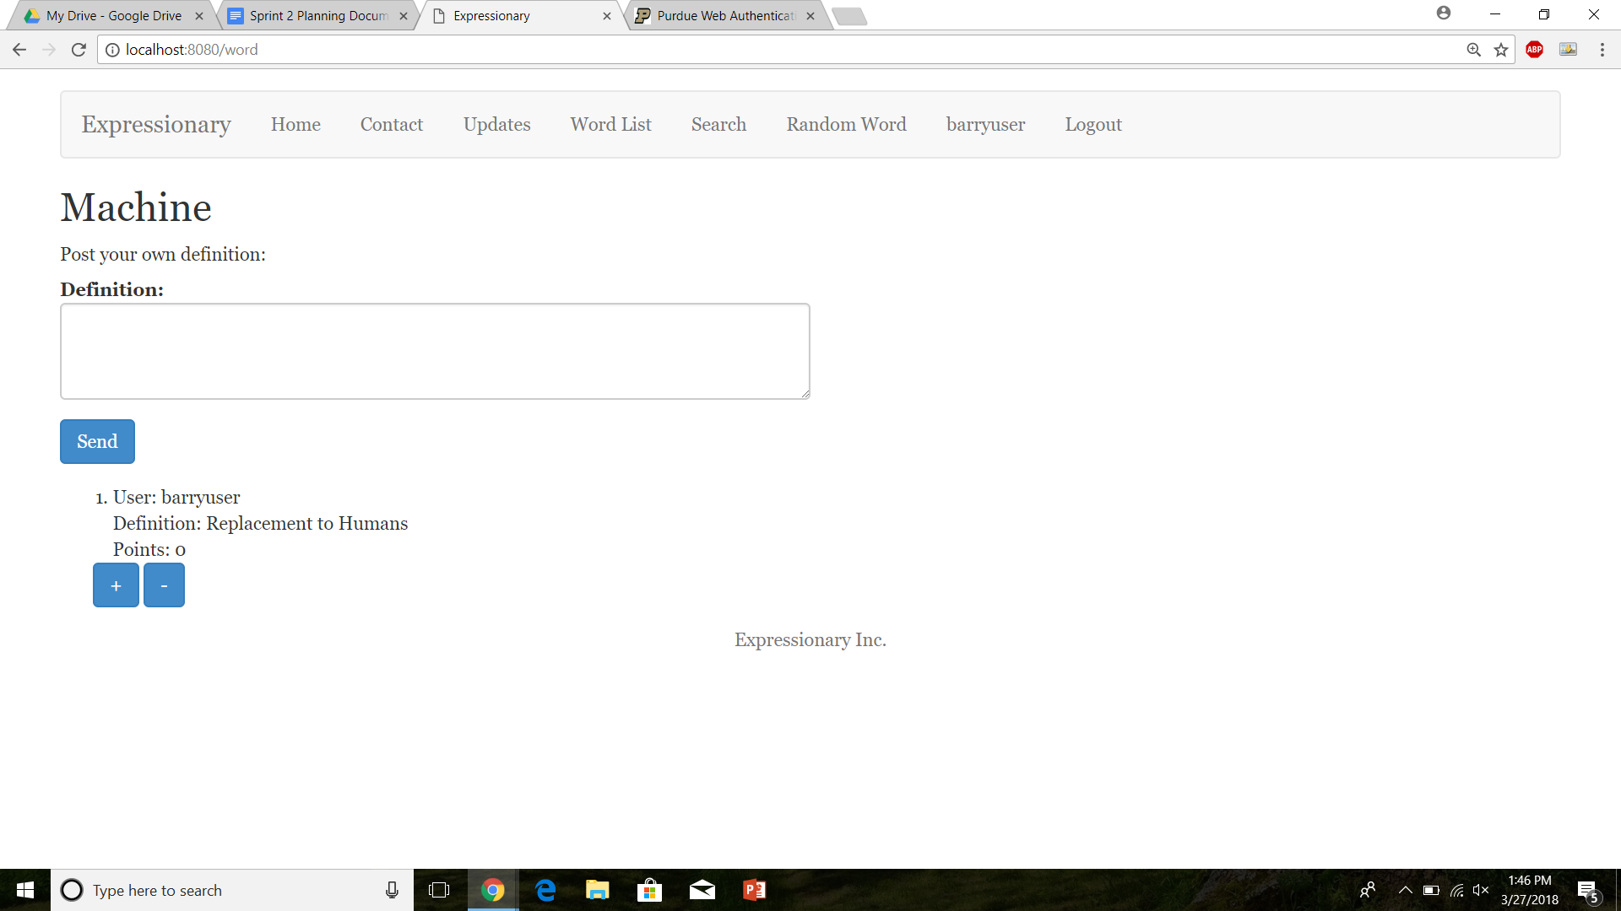

Navigate back to the user page

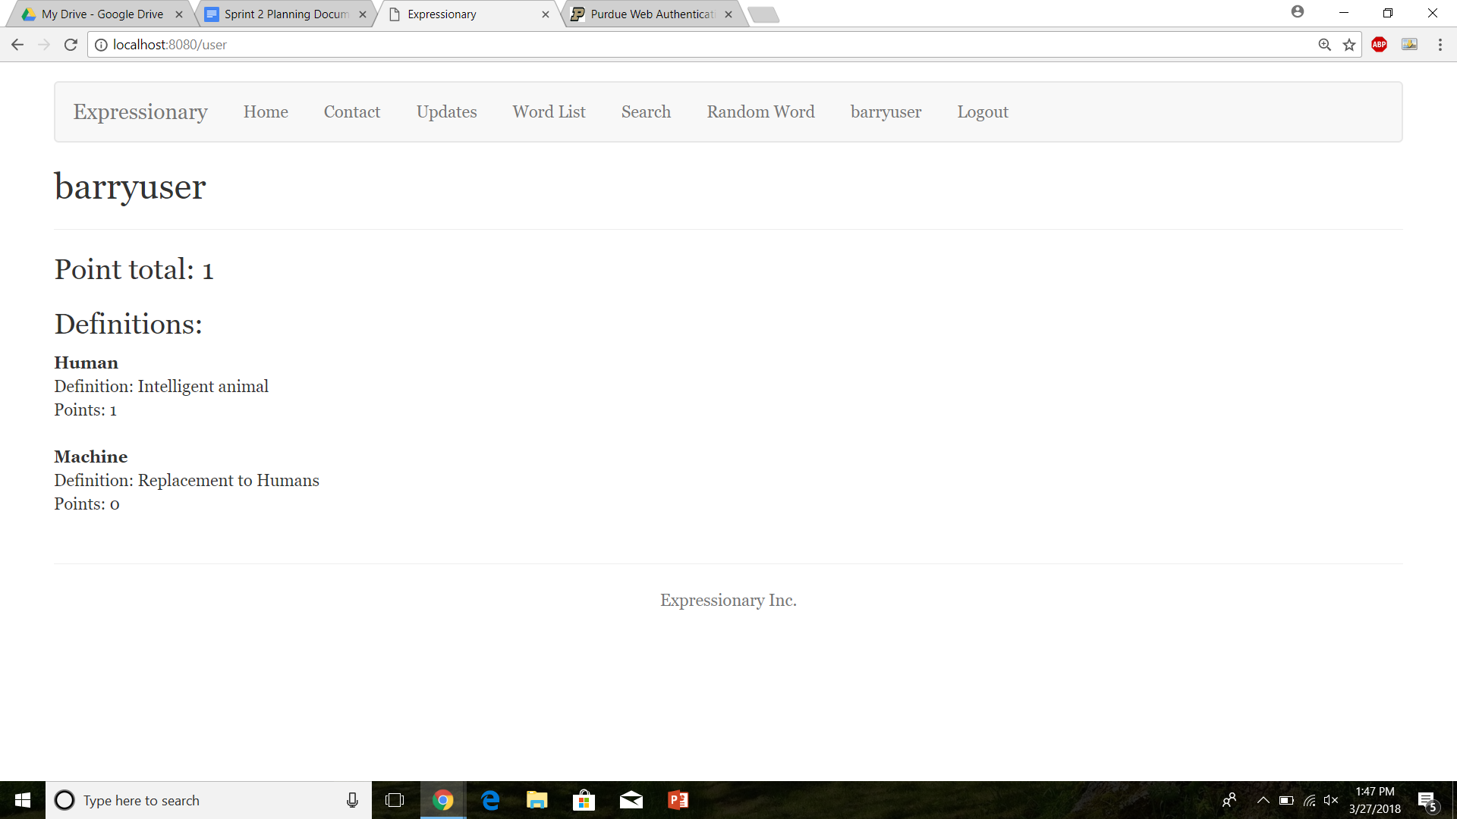

**Results:**

Definition gets added and is displayed on the user page.

**Test No.15**

Check to see if a different user adding a point to a definition also increases the total points of the user who posted the definition

**Procedure:**

* Login with valid credentials
* Check the profile page of a different user
* Find a definition posted by above mentioned user
* Decrement a point
* Check the profile page again

**Test**

Log in as a valid user and access profile page of a different user

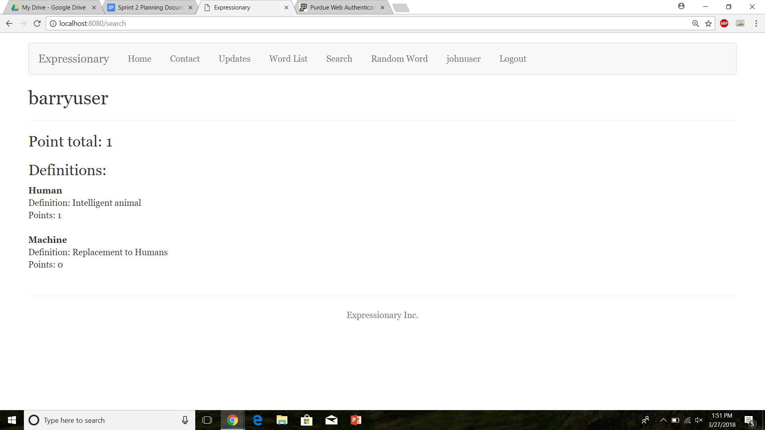

Decrement a point to one of the accessed user’s definitions

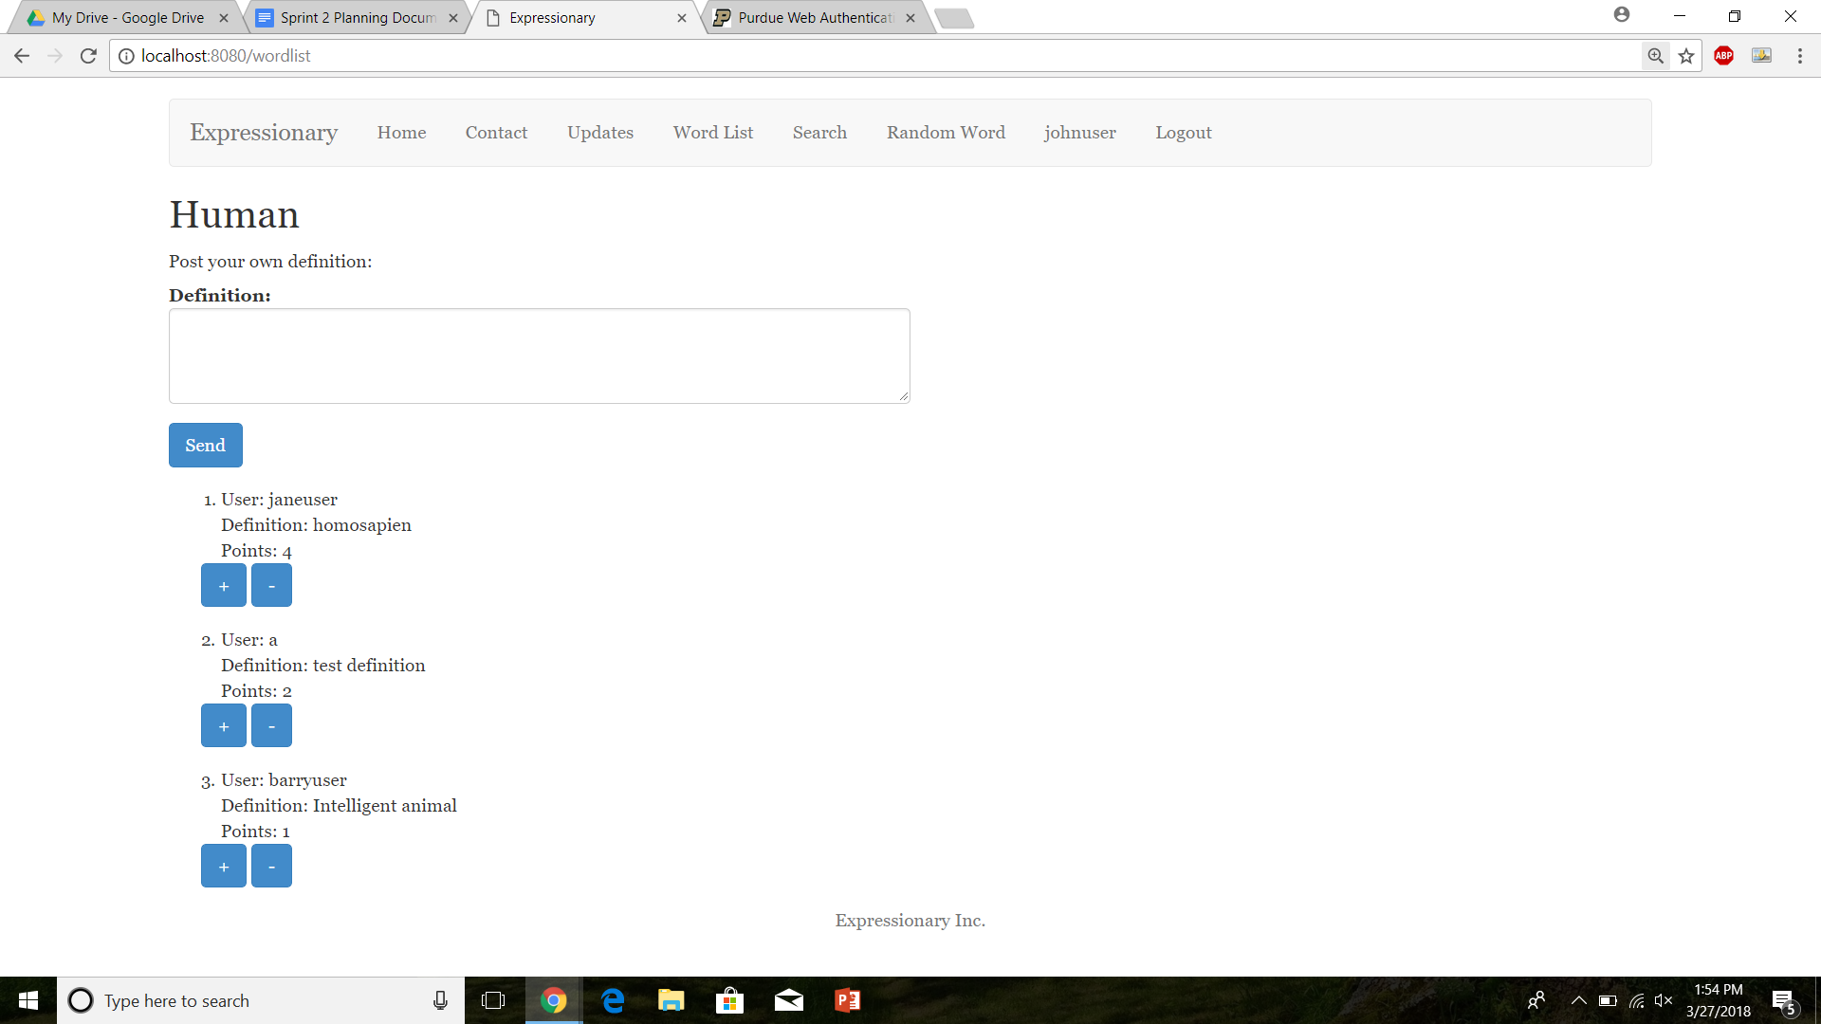

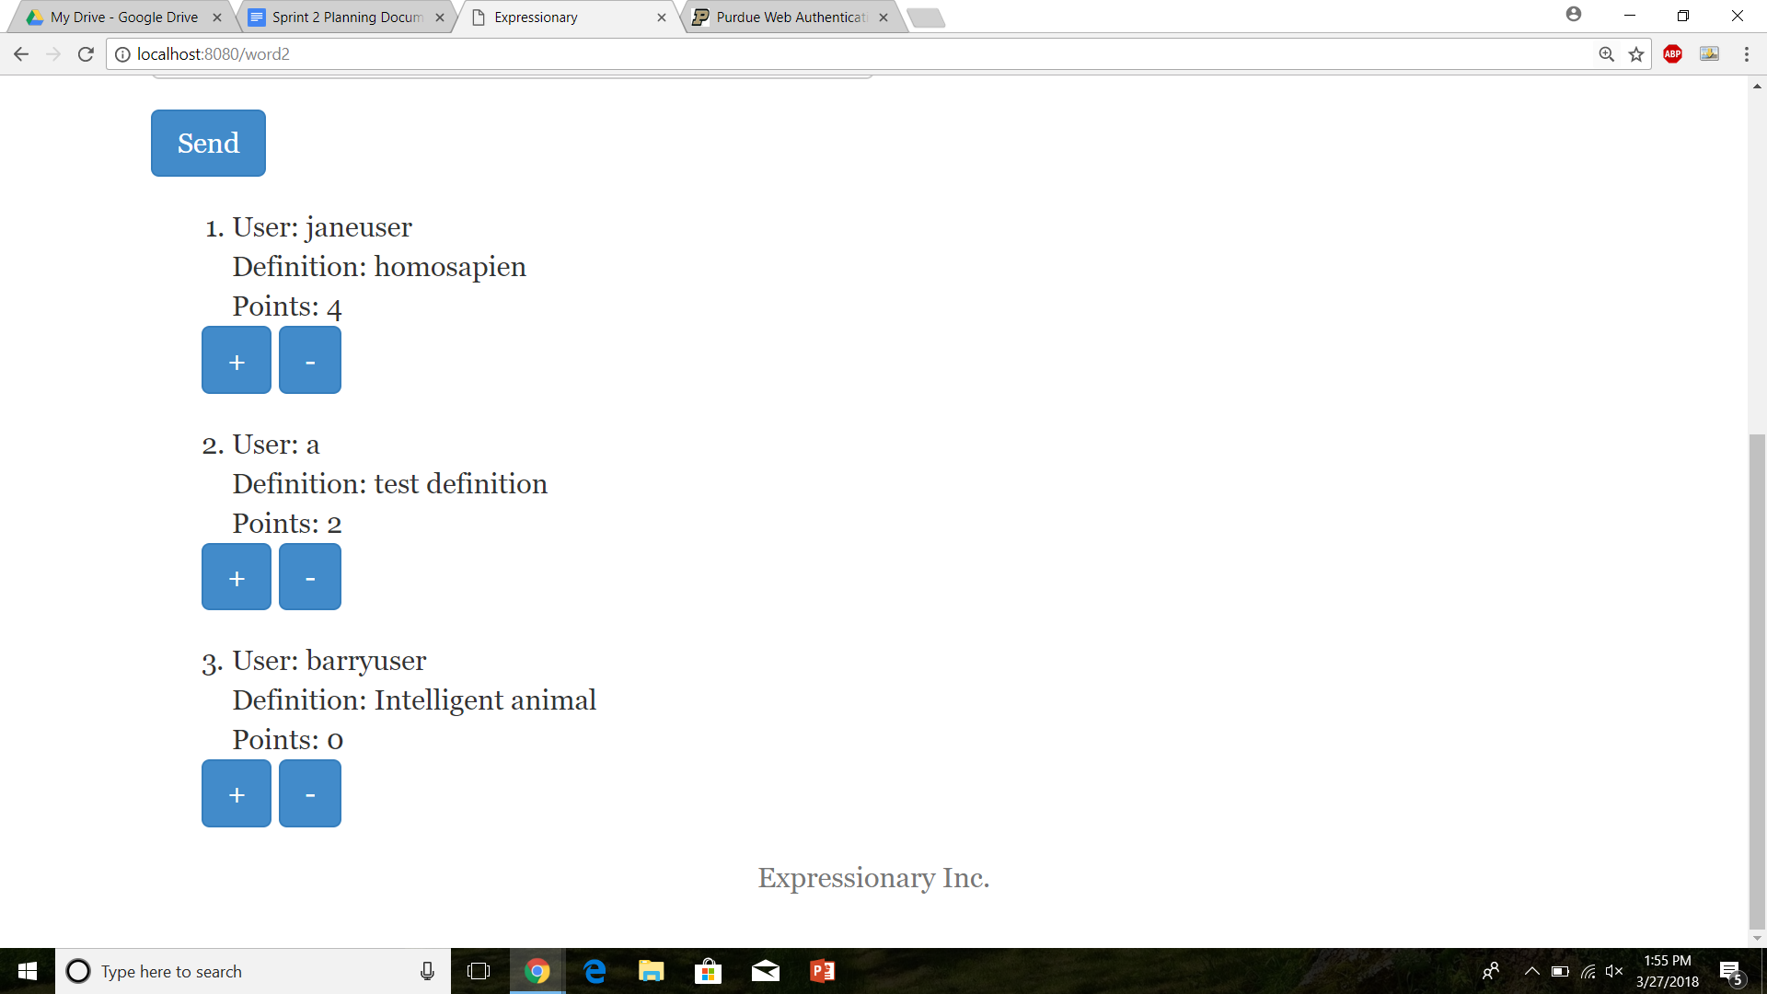

Visit the profile page again

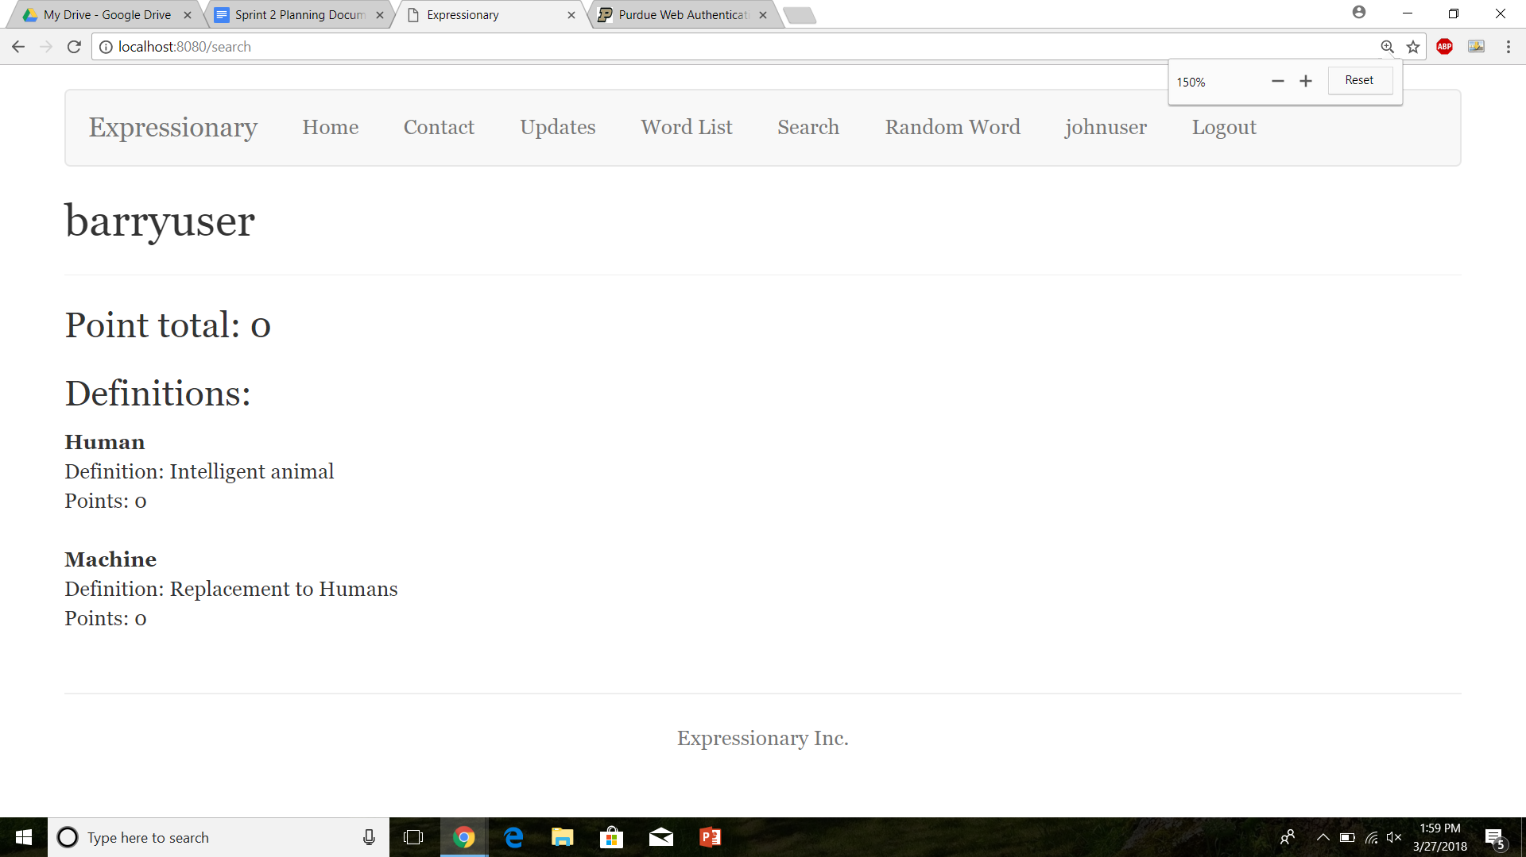

Report the response

**Results:**

The points get updated properly in the user page when points are changed from a different user as well

**Test No.16**

Robustness to see if the total points increment/decrement properly on the user page with multiple users.

**Procedure:**

* Login with valid credentials
* Check the profile page of a different user
* Find a definition posted by above mentioned user
* Decrement a point
* Check the profile page again
* Repeat with different users

**Test**

Initial profile page



Increment with ID no 1

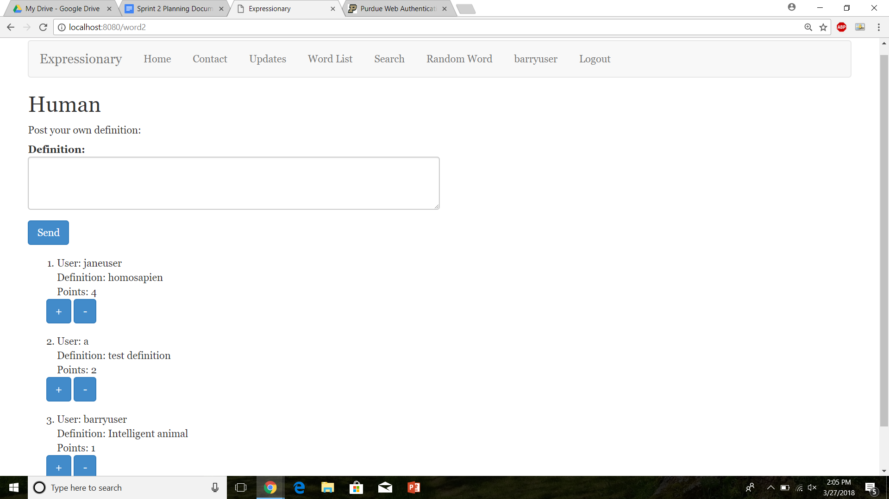

Increment with ID no2

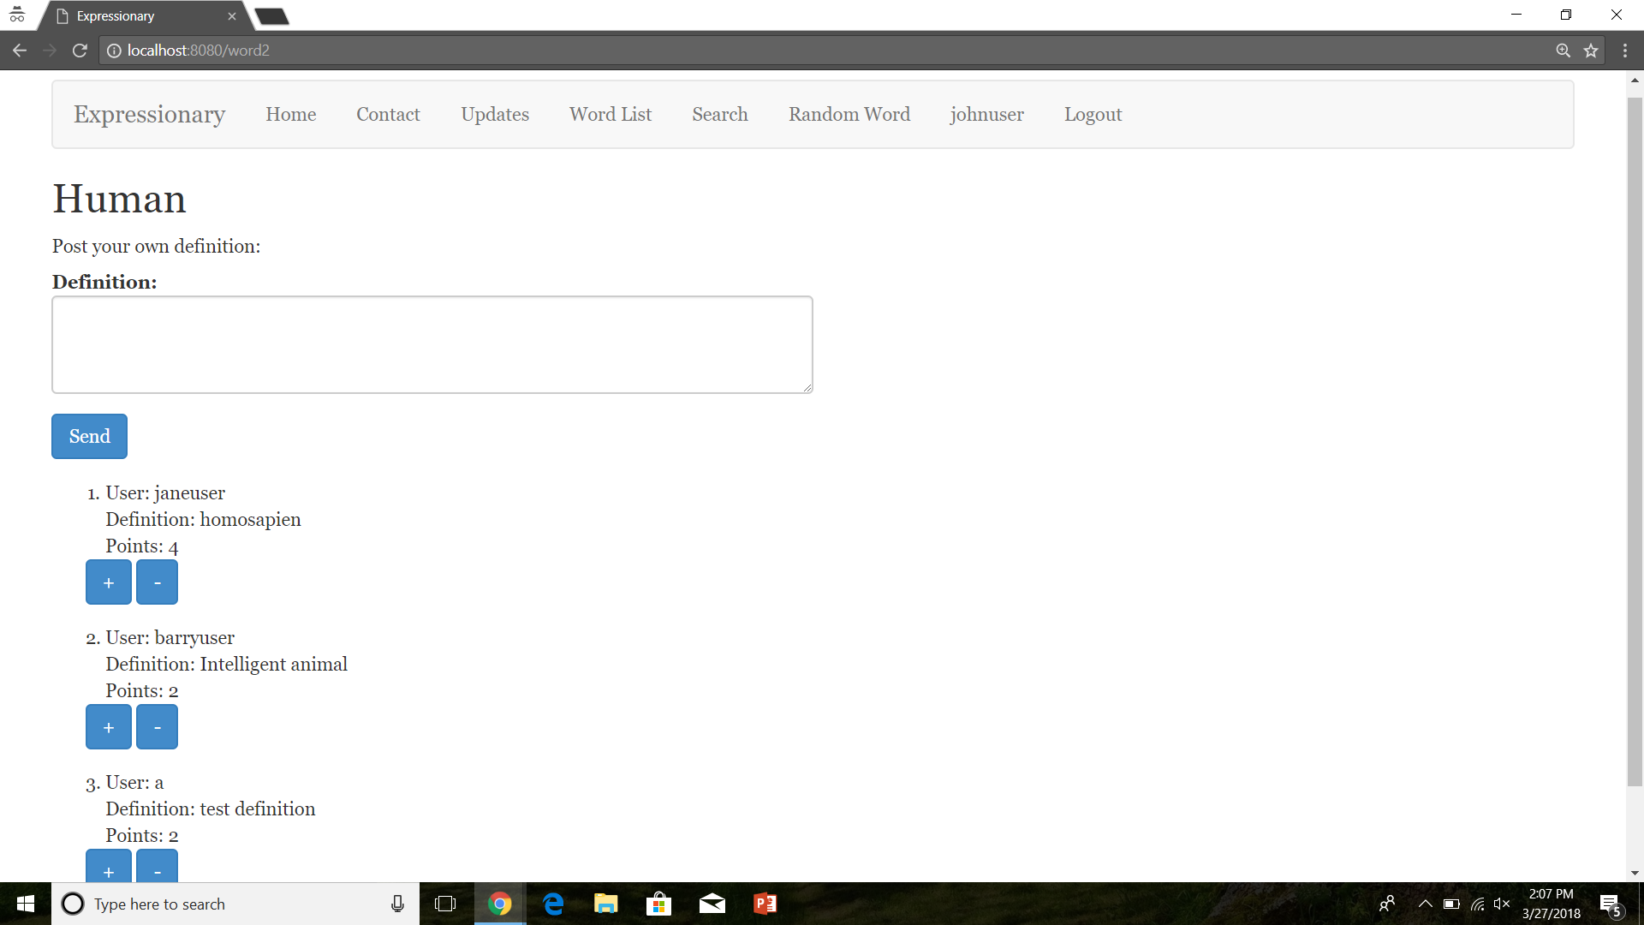

Increment with ID no3

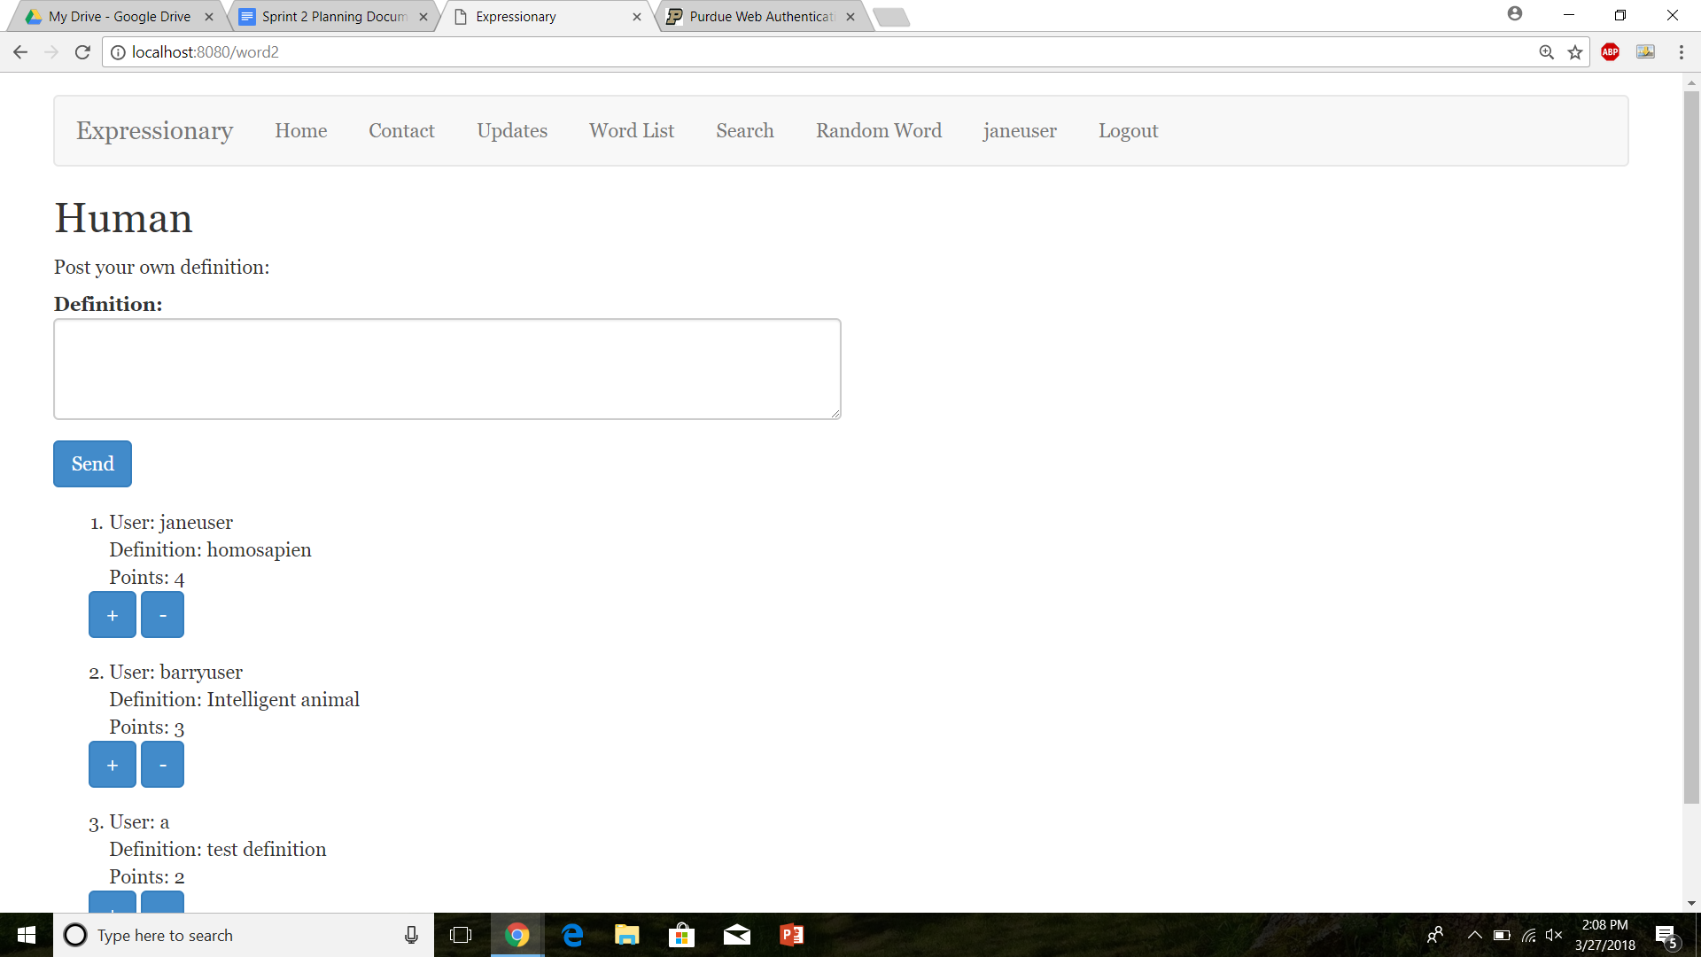

Check the profile again

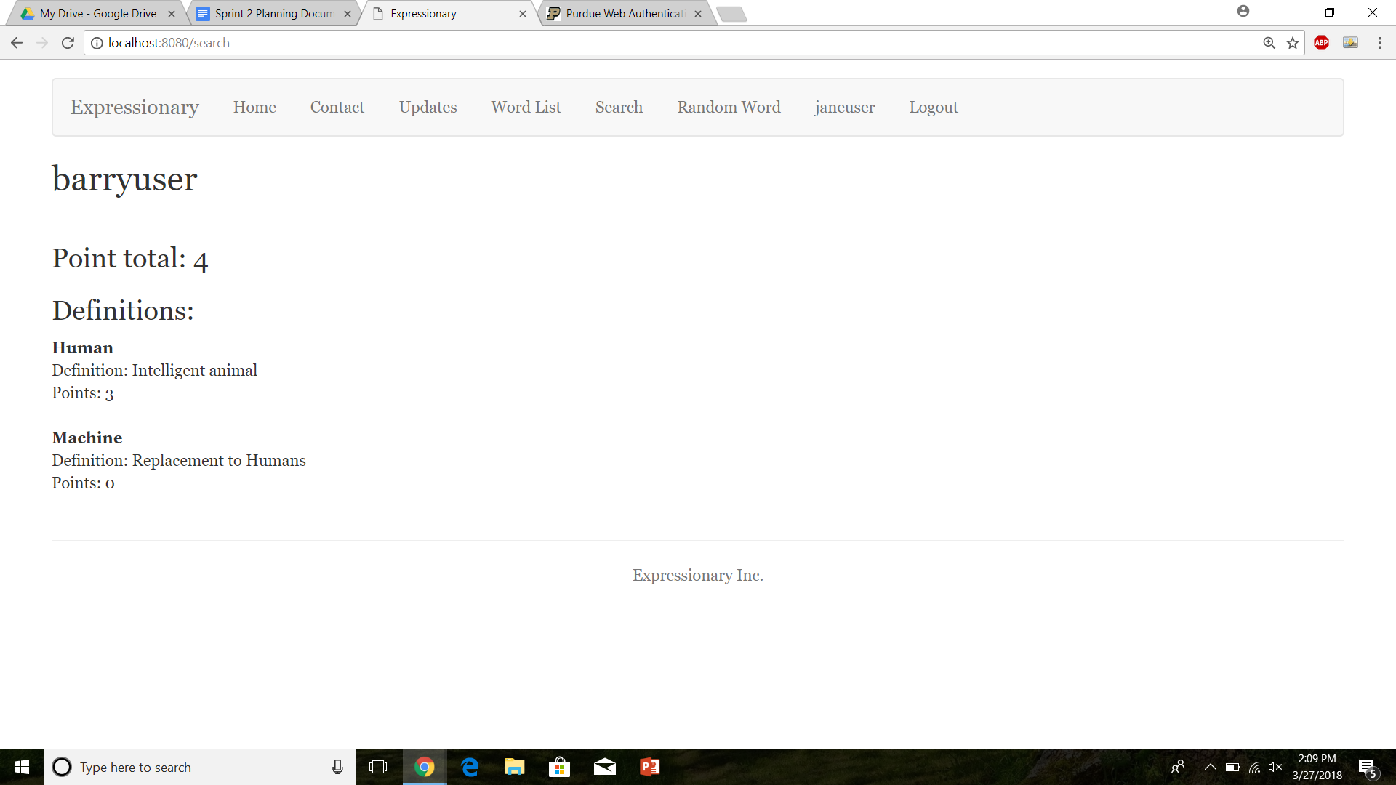

**Results:**

The points were incremented with all 3 users incrementing the point. The user page reflects the change.

**USER STORY #6**

**Test No.1**

Test to see if home page displays the users

**Procedure:**

* Navigate to the home page
* Report the response

**Test**

Navigate to the home page



Report the response.

**Results:**

We can see that there is a list of users being displayed on the home page, this is what we were expecting.

**Test No.2**

Test to see if anyone can view the users, non-logged in users and non-registered users

**Procedure:**

* Navigate to the home page
* Report the response

**Test**

Navigate to the home page



Report the response.

**Results:**

We can see that there is a list of users being displayed on the home page, without the need to register or log in this is what we were expecting.

**Test No.3**

Test to see if home page displays the users for logged in users

**Procedure:**

* Login with valid credentials
* Navigate to the home page
* Report the response

**Test**

Login and then Navigate to the home page

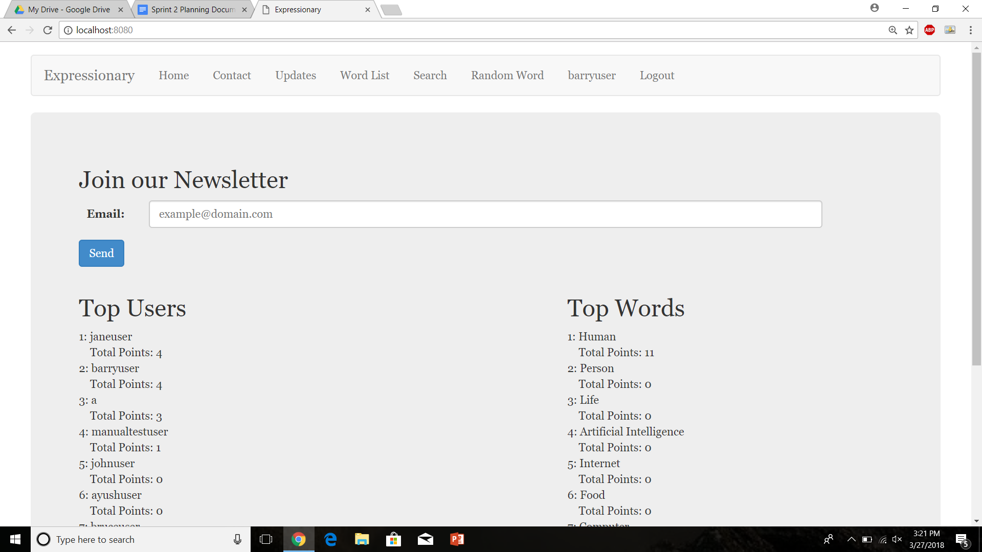

Report the response.

**Results:**

We can see that there is a list of users being displayed on the home page for the logged in users, this is what we were expecting.

**Test No.4**

Test to see if home page displays the users in the correct order, descending order

**Procedure:**

* Navigate to the home page
* Observe the order of the user list
* Report the response

**Test**

Navigate to the home page



Report the response.

**Results:**

The users are in ascending order which is what we were expecting from the top user page.

**Test No.5**

Navigate to a different page and back to see if the website breaks upon changing pages.

**Procedure:**

* Navigate to the home page
* Navigate to a different page
* Navigate to back to home page
* Report the response
* Repeat

**Test**

Navigate to the home page



Navigate to a different page

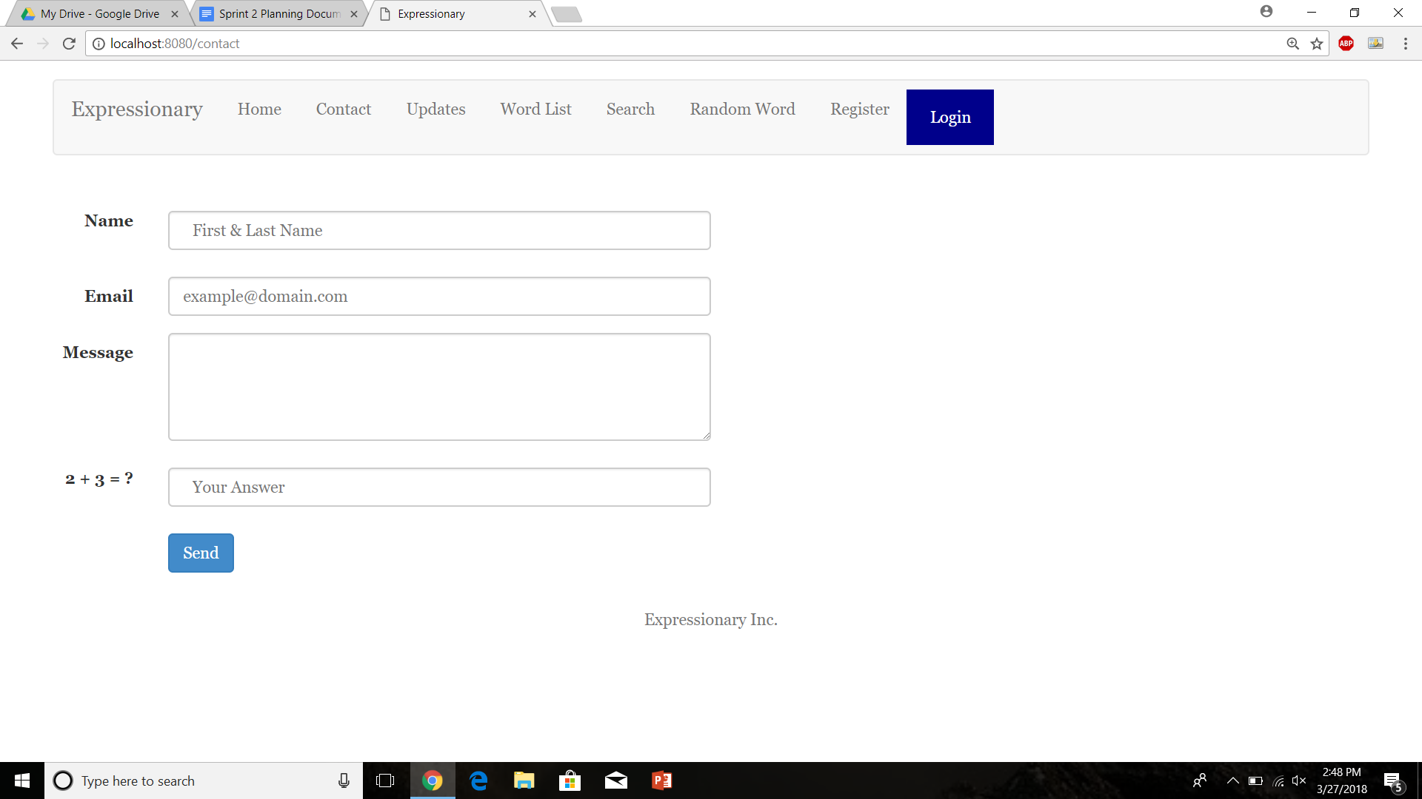

Navigate to the home page



Navigate to a different page

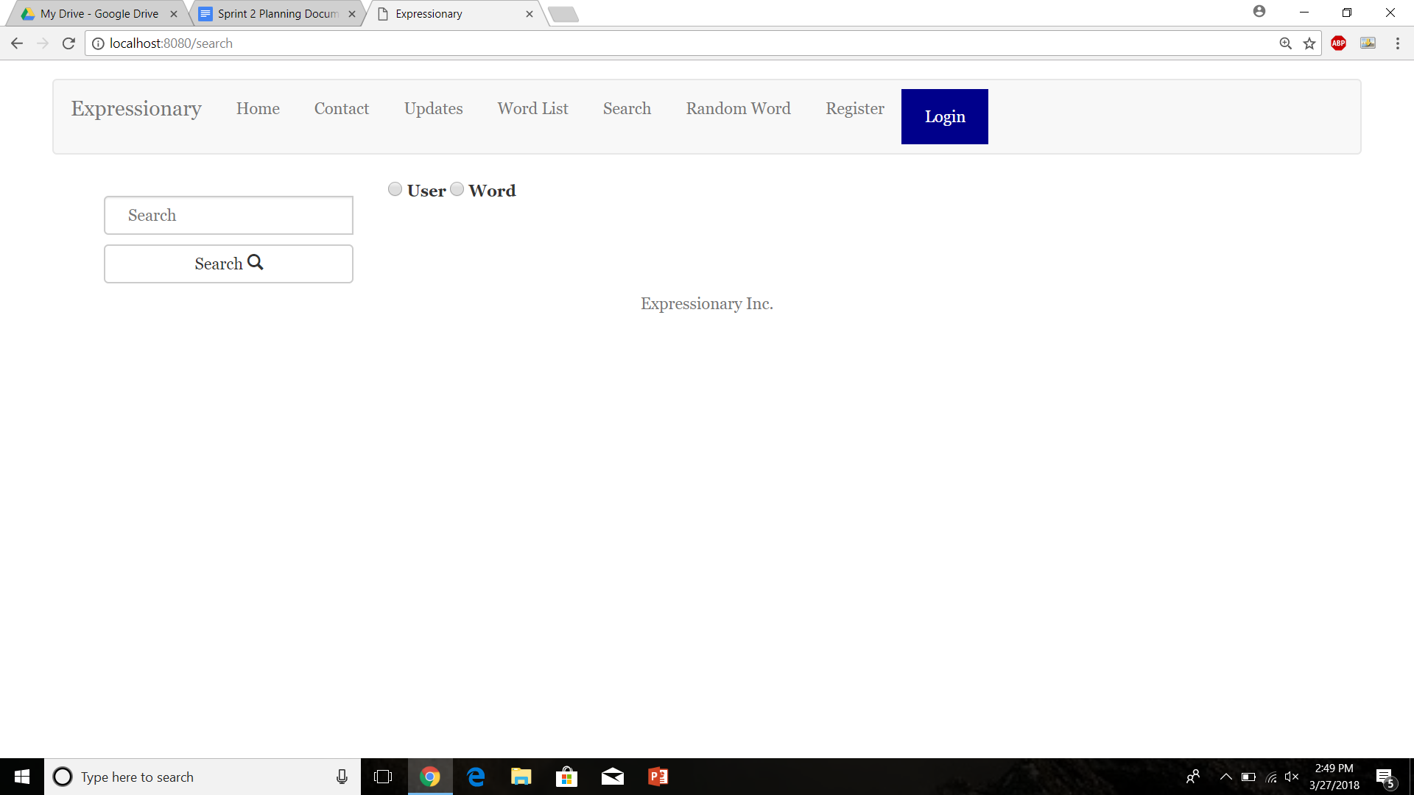

Navigate to the home page



**Results:**

The list of users remains the same and does not breaking upon changing pages

**Test No.6**

Register with a new user and see if the user shows in the list (Since the list is small right now he should show up)

**Procedure:**

* Navigate to the register user page
* Register with valid credentials
* Navigate back to home page
* Report the response

**Test**

Register a user

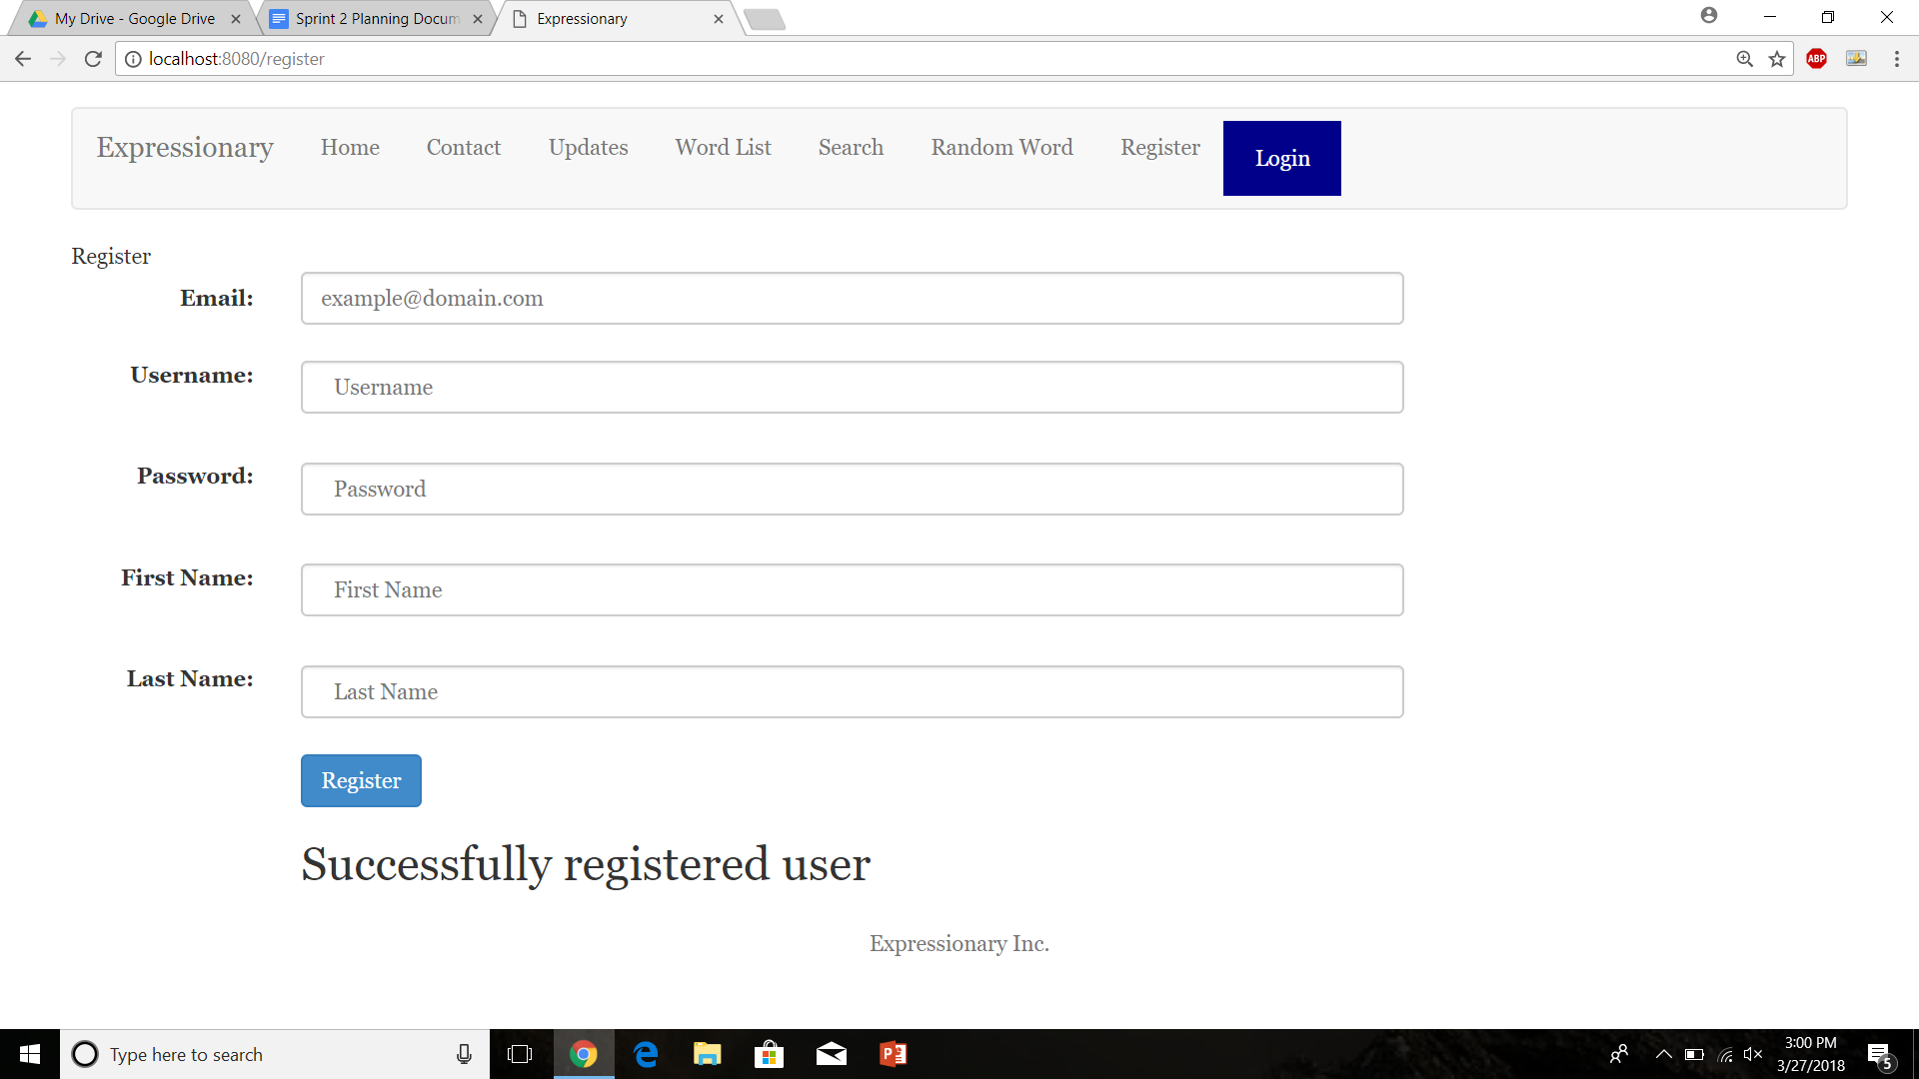

Navigate back to home page

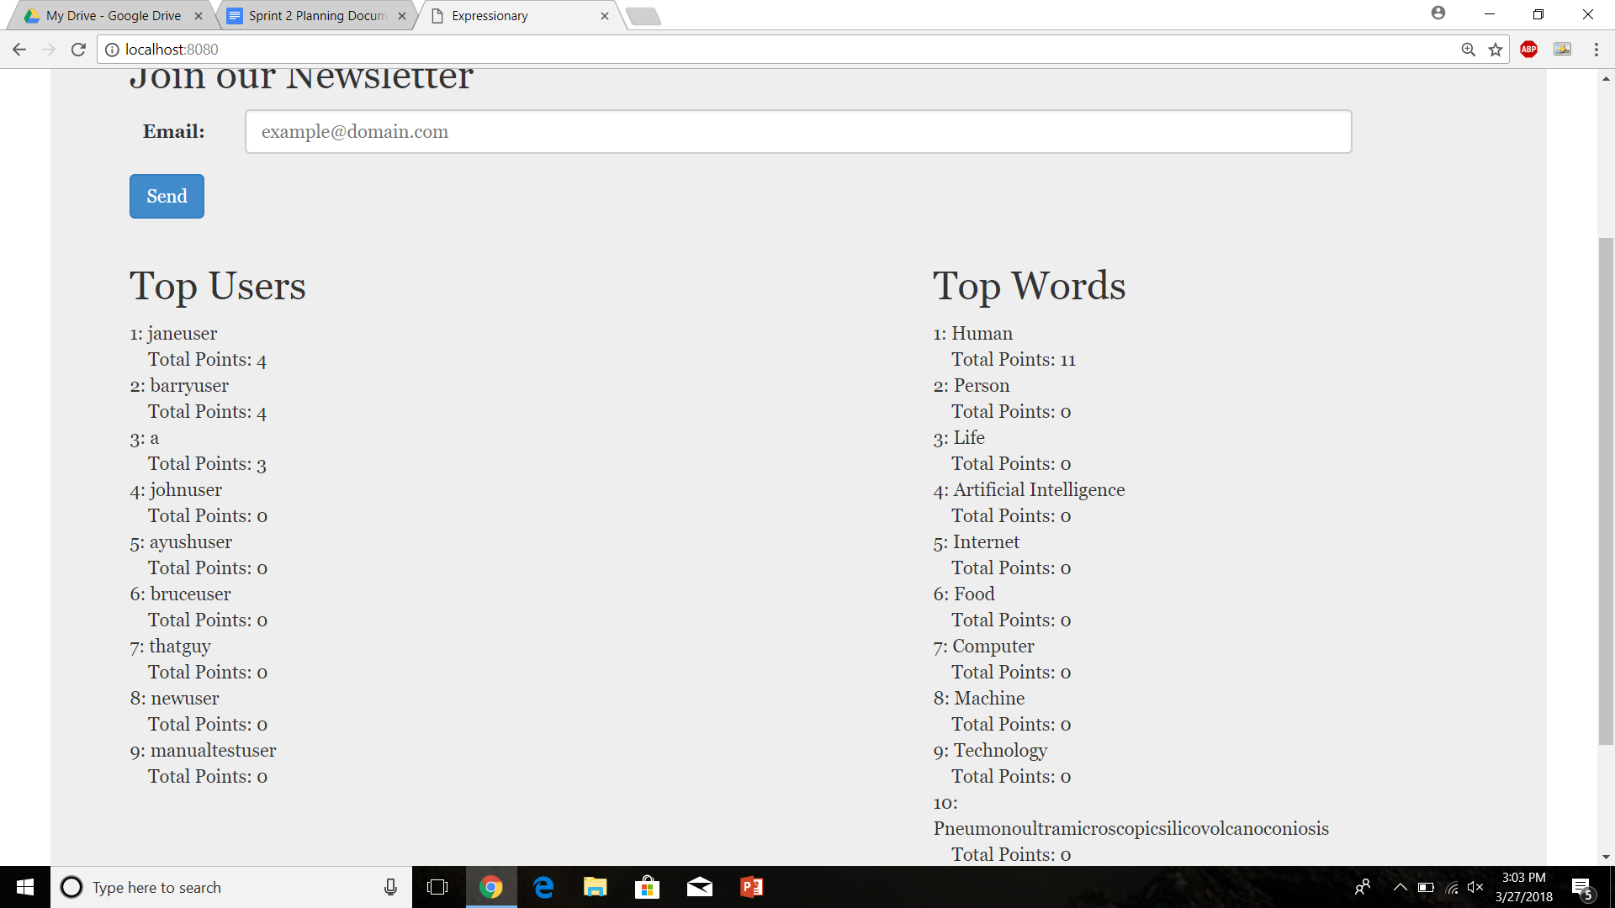

Report the response

**Results:**

Since the user does show up at the bottom, the results are as expected

**Test No.7**

Test to see if newly registered users can climb up the top user list

**Procedure:**

* Login as the new user
* Navigate to the home page
* Find a definition posted by the user and add a point to it
* Navigate back to the home page
* Report the response

**Test**

Navigate to the home page



Add points to the user’s definition.

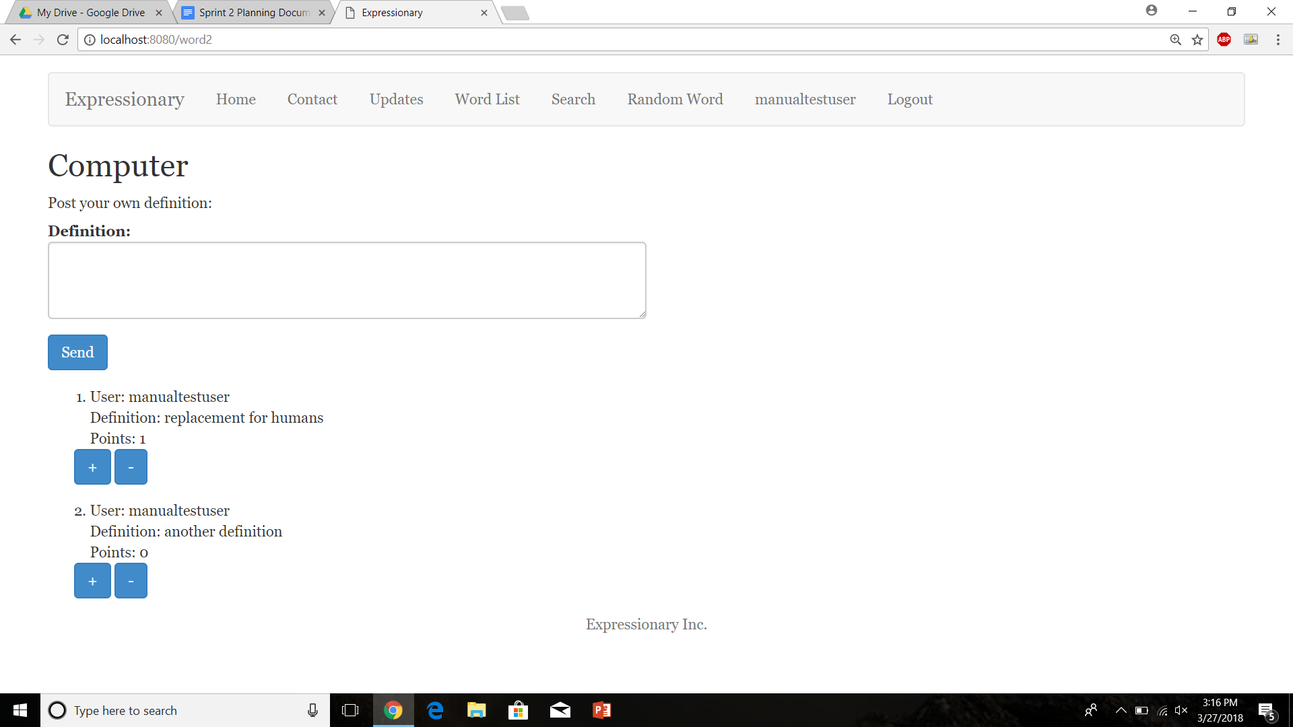

Navigate back to the home page

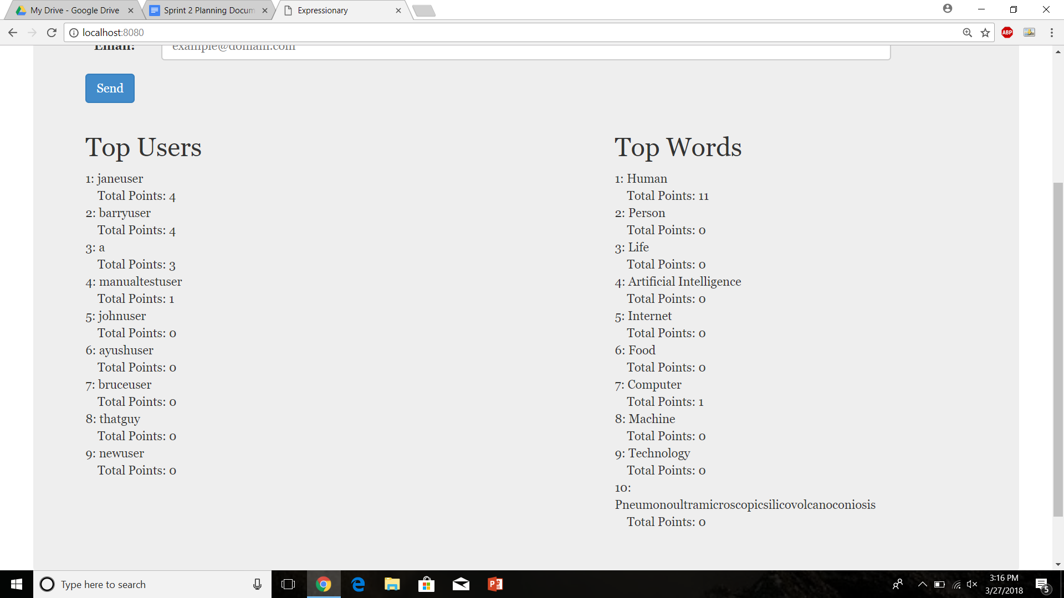

Report the response

**Results:**

The newly registered user moved up in the ranks which mean, the result was expected.

**Test No.8**

Test to check if point decrementing shows up on the leaderboard.

**Procedure:**

* Login with valid credentials
* Decrement a vote from one of user’s definitions
* Navigate to home page
* Report the response

**Test**

Login with valid credentials

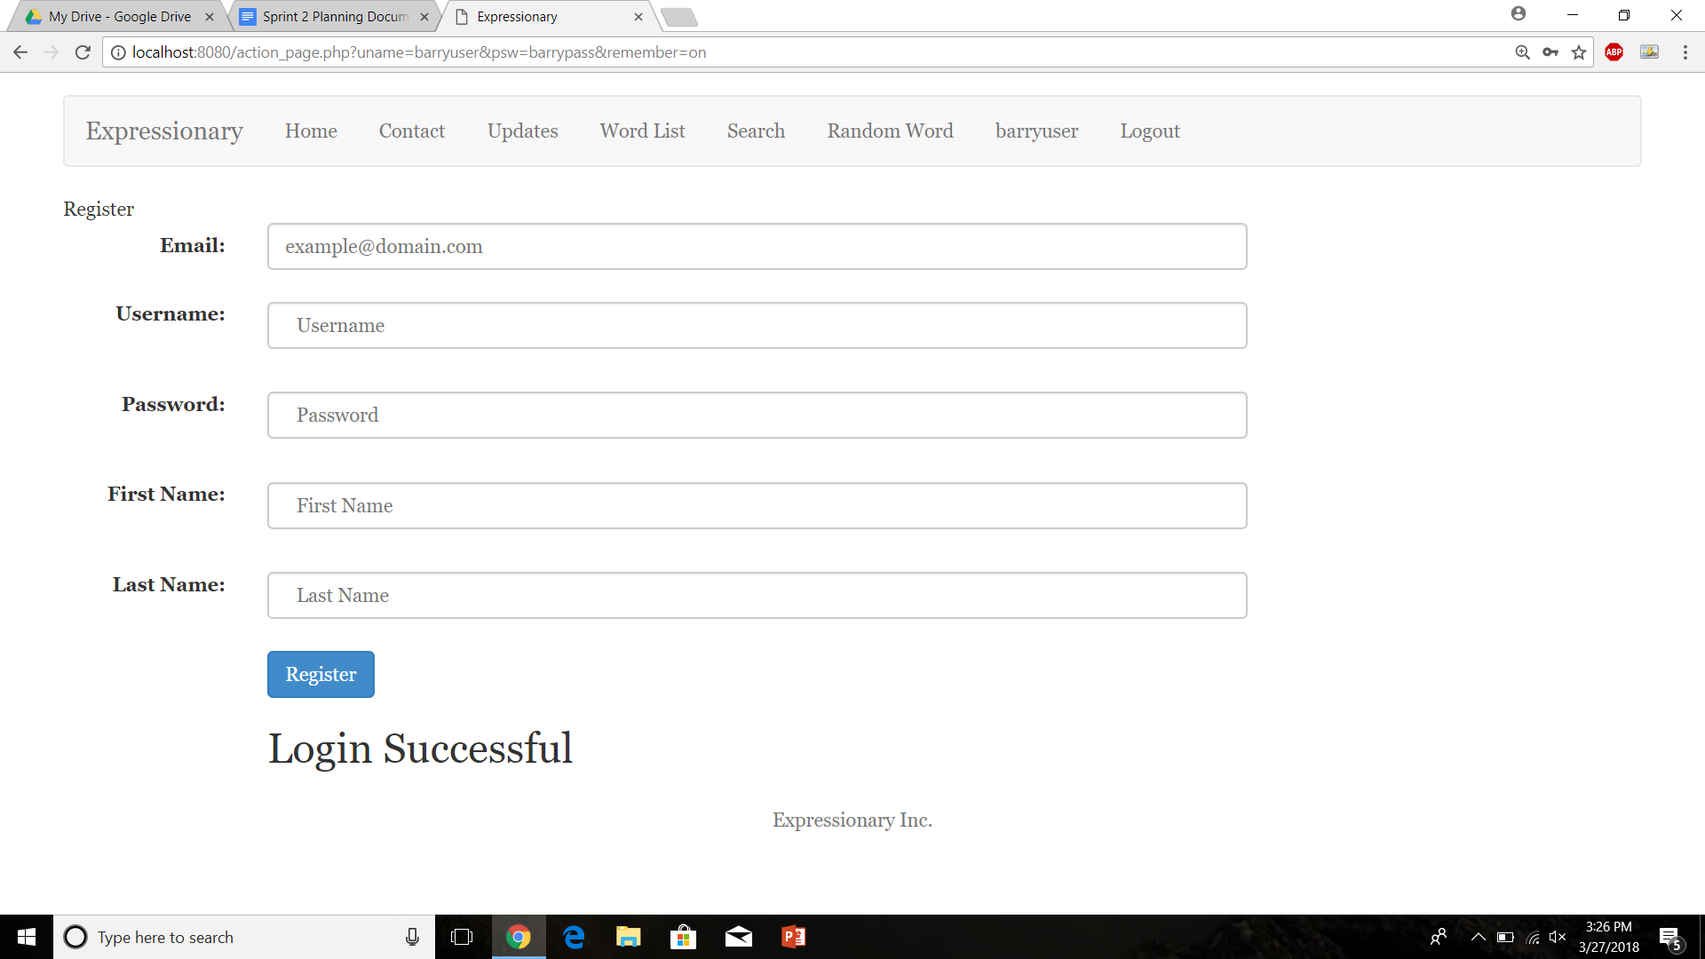

User in the list before the change of points

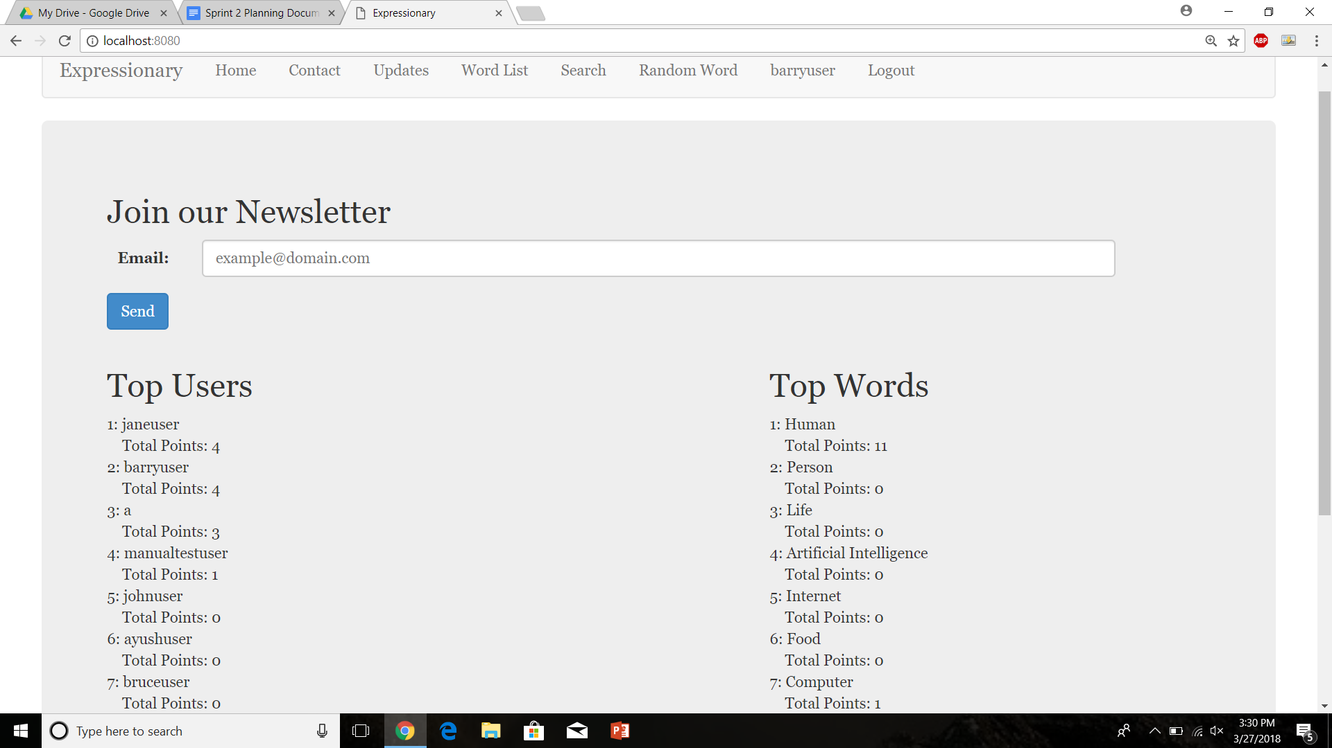

Decrement a vote from a definition

User in the list after the change of points

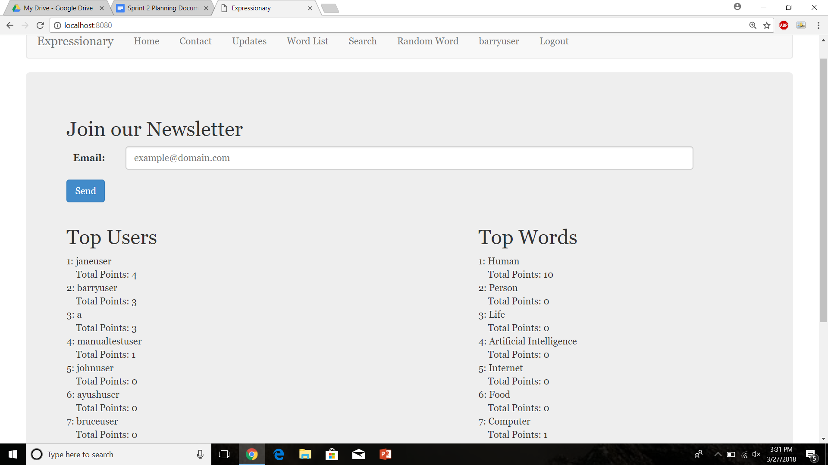

Report the response.

**Results:**

The points did change on the home page indicating that the user’s definition was voted down, the result was expected

**Test No.9**

Test to check if point incrementing shows up on the leaderboard.

**Procedure:**

* Login with valid credentials
* Increment a vote from one of user’s definitions
* Navigate to home page
* Report the response

**Test**

Login with valid credentials



User in the list before the change of points



Increment a vote from a definition

User in the list after the change of points



Report the response.

**Results:**

The points did change on the home page indicating that the user’s definition was voted up, the result was expected

**Test No.10**

Test to see if users can move up in the list by changing of votes

**Procedure:**

* Login with valid credentials
* Increment a vote from one of user’s definitions
* Increment enough times to change leaderboard
* Navigate to home page
* Report the response

**Test**

Login with valid credentials



Leaderboard before incrementing points

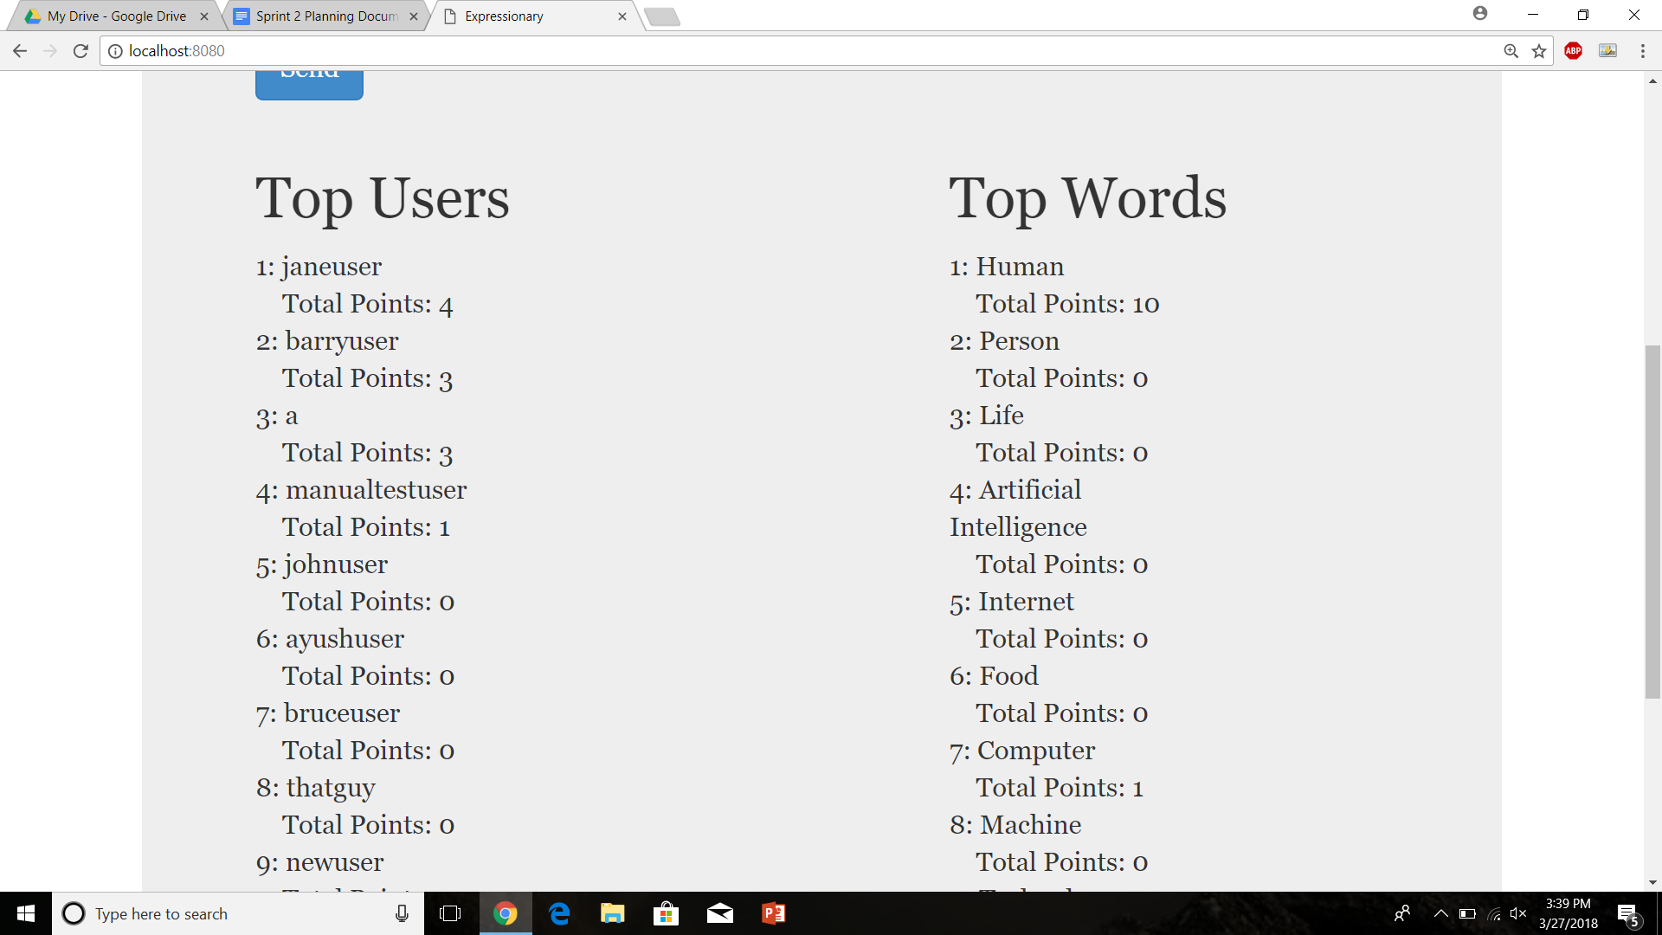

Leaderboard after incrementing the points

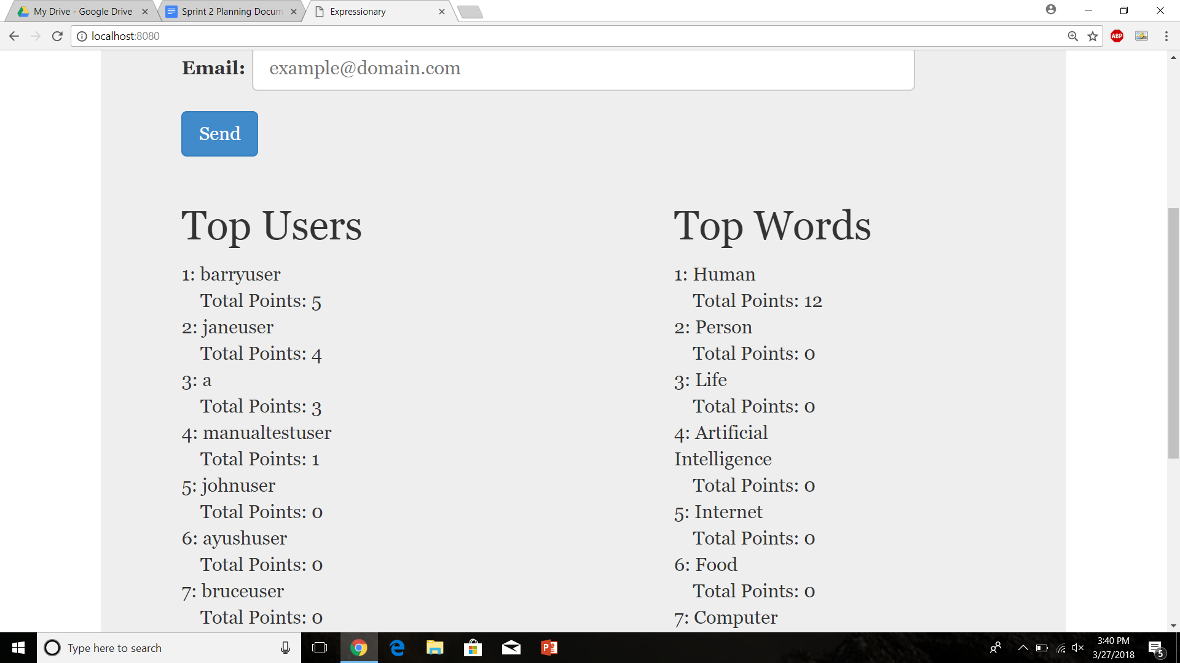

Report the response

**Results:**

The user “barryuser” was moved up in the list when his posts points were incremented, The result was expected.

**Test No.11**

Test to see if users can move down in the list by changing of votes

**Procedure:**

* Login with valid credentials
* decrement a vote from one of user’s definitions
* decrement enough times to change leaderboard
* Navigate to home page
* Report the response

**Test**

Login with valid credentials



Leaderboard before decrementing points



Leaderboard after decrementing the points



Report the response

**Results:**

The user “barryuser” was moved down in the list when his posts points were incremented, the result was expected.

**Test No.12**

Test to check if non-logged users voting does not affect the user leaderboard.

**Procedure:**

* Navigate to the home page
* Try to increment a vote without logging in
* Return to the home page
* Report the response

**Test**

Navigate to the home page

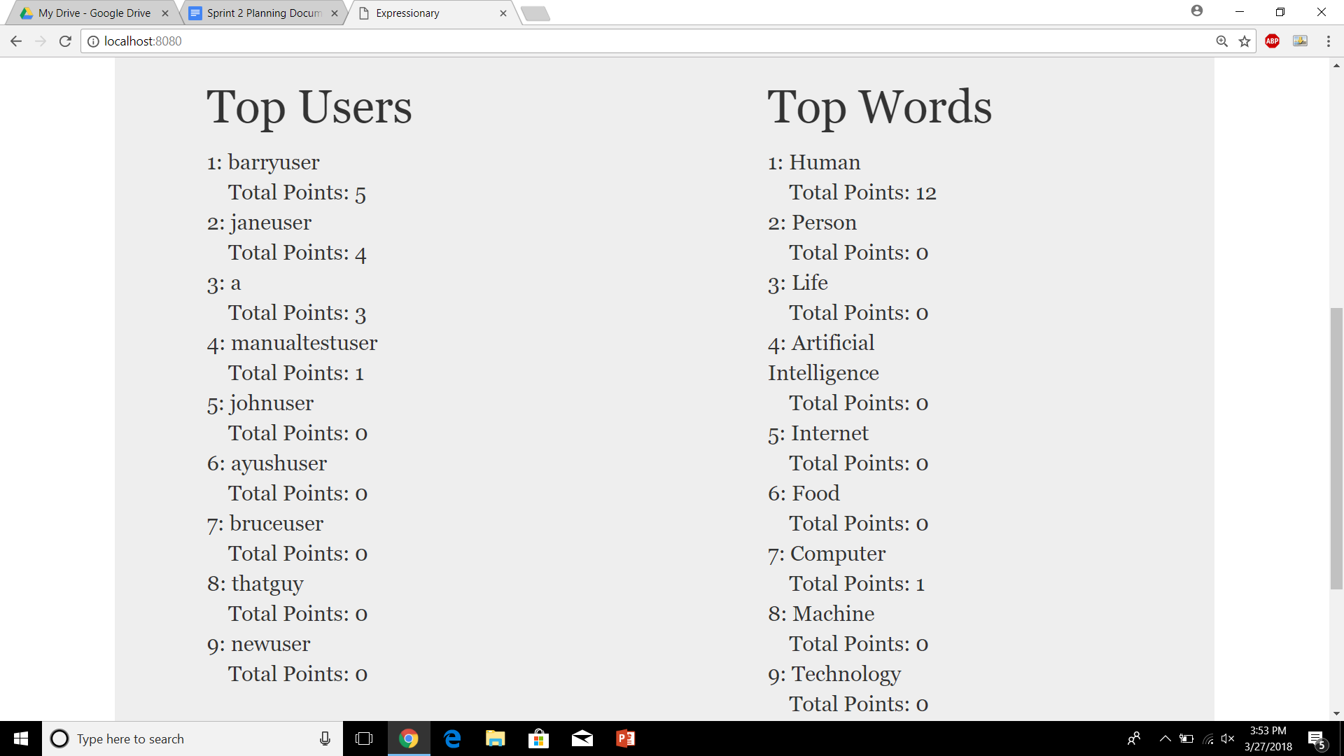

Try to vote

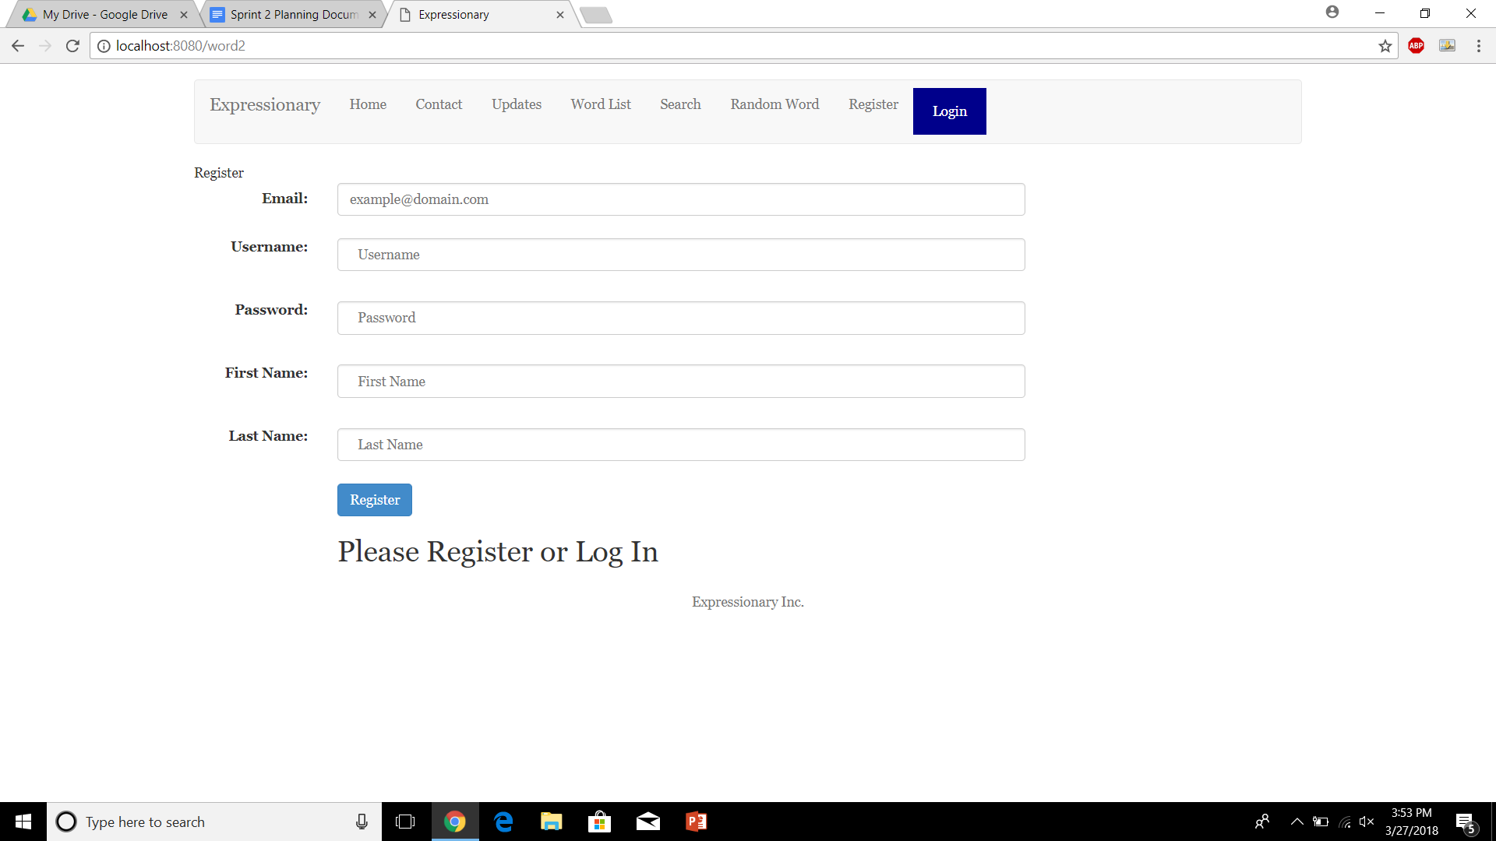

Navigate back to the leaderboard



Report the response

**Results:**

The list of users remained the same as before, the illegal vote did not affect the leaderboard. This is what we were expecting.

**Test No.13**

Robustness test to check if multiple tries of a user trying to vote without logging in also does not work.

**Procedure:**

* Navigate to the home page
* Try to increment a vote without logging in
* Return to the home page
* Report the response

**Test**

Navigate to the home page



Try to vote



Navigate back to the leaderboard



Report the response

Repeat

Leaderboard After trying to vote many times without logging in.



**Results:**

The list of users remained the same as before, the illegal vote did not affect the leaderboard even if done several or multiple times. This is what we were expecting.

**Test No.14**

Backend test to make sure the only users being displayed are the ones that were legally registered i.e. no illegal users are being displayed/ database is not corrupted

**Procedure:**

* Navigate to the home page
* Compare users with the database
* Report the response

**Test**

Navigate to the home page



Compare users with the database

The database is not being displayed over here to keep code safe

Report the response.

**Results:**

The only users being displayed were from the database, this is the expected result.

**Test No.15**

Robustness to check if user can climb up the leaderboard multiple times

**Procedure:**

* Navigate to the home page
* Login with valid credentials
* Get enough votes for a user for him to climb up the leaderboard multiple times
* Navigate back to home page
* Report the response

**Test**

Navigate to the home page



Increment the scores enough times for him to move up in the leaderboard

Repeat until appropriate

Leaderboard after incrementing the points

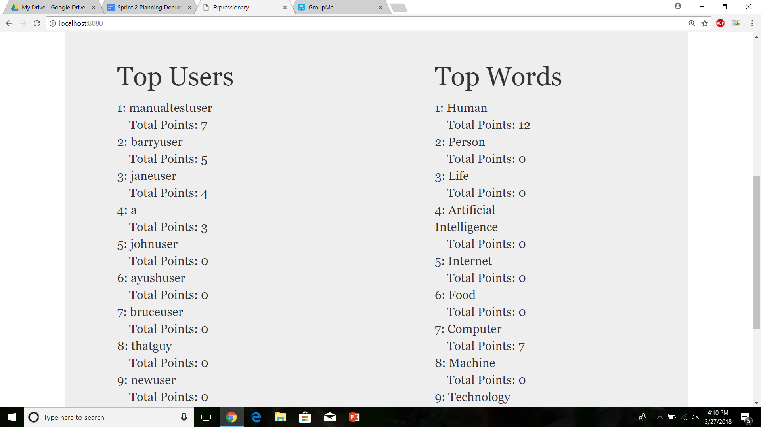

**Results:**

The user climbed from no.4 to no.1 in the leaderboard when his points were incremented enough times. This was the expected result.

**Test No.16**

Robustness to check if user can climb down the leaderboard multiple times

**Procedure:**

* Navigate to the home page
* Login with valid credentials
* Get enough votes for a user for him to climb down the leaderboard multiple times
* Navigate back to home page
* Report the response

**Test**

Navigate to the home page



decrement the scores enough times for him to move up in the leaderboard

Repeat until appropriate

Leaderboard after decrementing the points



**Results:**

The user fell from no.1 to no.4 in the leaderboard when his points were decremented enough times. This was the expected result.

**USER STORY #7**

**Test No.1**

Test to see if home page displays the words

**Procedure:**

* Navigate to the home page
* Report the response

**Test**

Navigate to the home page



Report the response.

**Results:**

The word page displays the way It should

**Test No.2**

Test to see if anyone can view the word leaderboard, non-logged in users and non-registered users

**Procedure:**

* Navigate to the home page
* Report the response

**Test**

Navigate to the home page



Report the response.

**Results:**

We can see that there is a list of words being displayed on the home page, without the need to register or log in this is what we were expecting.

**Test No.3**

Test to see if home page displays the words for logged in users

**Procedure:**

* Login with valid credentials
* Navigate to the home page
* Report the response

**Test**

Login and then Navigate to the home page



Report the response.

**Results:**

We can see that there is a list of words being displayed on the home page for the logged in users, this is what we were expecting.